WWII Assignment
Objectives 1.1, 1.2, 1.3, 1.5, 3.3,
Fully answer the following using information you will gather from researching the questions. Put the information into your own words. For each question cite your sources as per the examples provided. You will cite your sources and create a bibliography of your sources in Chicago Turabian Style.
Turning Points of World War II
Choose 1 from each list
Europe/Africa  Moscow  Kursk  D-Day  El Alamein  Battle of the Bulge  Stalingrad  Monte Cassino | Pacific  Midway  Okinawa  Iwo Jima  Leyte Gulf  Coral Sea
Describe the significance of two WWII battles.
BACKGROUND INFORMATION
At the very minimum you should have:
Who were the belligerents?
When did the battle take place?
Where the battle took place?

THE BATTLE
At the very minimum you should have:
Why did the battle take place?
Each side has a reason for fighting at this particular place. Why is this battle strategically significant for each side?
Who was successful? Why successful?
Why unsuccessful?

Be sure to include:
At least two cited sources for each battle. (You will cite the sources below each battle and in your bibliography.)
Other considerations:
Maps
Pictures
Graphs
Tables
Min. 2 sources per battle

OVERALL SIGNIFICANCE
At the very minimum you should have:
How did the outcome of the battle affect the war moving forward?
Were there any lessons learned during this battle that would be taken into consideration moving forward in the war?

Images of the Holocaust
Reference: Guide Holocaust images (feel free to use sites you find yourself) http://fcit.usf.edu/holocaust/timeline/timeline.htm
http://www.phdn.org/histgen/schmitz/indexeng.html
http://www.jewishvirtuallibrary.org/jsource/Holocaust/phototoc.html

Task: Perhaps no other event in recent human history has as powerful a visual record as the holocaust. Search the internet for images of the holocaust and construct a slideshow of powerful images. Copy and paste the images into the following table, along with Chicago style citation. (You will add the citations to the bibliography.) Under the annotation heading provide a brief description of what is happening in the image and why you chose that particular image. 10-12 images is enough as you want to focus on quality, not quantity, choosing images that are meaningful to yourself and provide depth to your understanding of the events of the holocaust. Be sure to paste your images in chronological order to create a narrative and show the evolution of the Holocaust as it occurred in Nazi controlled Europe.

Example (You many not use this image in your assignment.)
Image | Annotation
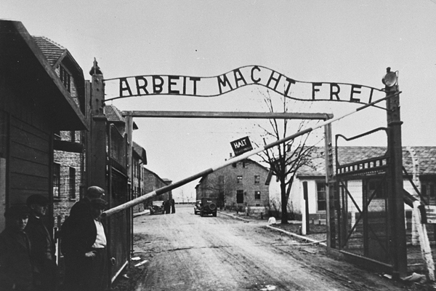 | This image shows the sign over the gate at the Auschwitz/Birkenau concentration camp. All new arrivals to the camp would enter through this gate.  I believe this is an important image because of the message above the gate. The message says “Work will set you free.” The Nazis used this phrase on the gates of many concentration camps. The phrase was used to deceive those arriving at the camps to try and make them believe that they were to be used as labourers with a chance of survival. The reality was that Jews would be freed, but only in death, through gas chambers, or through being worked to death.
Citation
"The Politics of History: Holocaust Denial and Distortion in Europe Today," United States Holocaust Memorial Museum, accessed December 11, 2021, https://www.ushmm.org/online-calendar/event/mwchiclawmeet1218

Dropping the Bomb
The United States did not just pick nuclear targets at random. You will research and explain why Hiroshima and Nagasaki were targeted by the United States for nuclear attacks.
First you must identify and explain the criteria used by the United States to select WWII nuclear targets.
Which of these criteria do feel is the most important? Why?
Which of these criteria do feel is the least important? Why?
Finally, you will discuss how the targets of (Hiroshima and Nagasaki) fit or did not fit each of the target criteria? (Cite the sources you use and add to bibliography.)

Technology that Changed the World.
Identify a new technology that was invented, introduced, or came to prominence during WWII. Provide a picture(s) of the technology along with a description its purpose, and groundbreaking technology, and its importance during the war.
Write a detailed paragraph(s) to discuss what significant impact the invention has had on society since WWII (How did it change the world?). Be sure to include appropriate explanation and examples. Cite your sources.

To Bomb, or not to Bomb? That is the Question. (Multiple paragraph answer)
Some people believed that the Japanese were defeated prior to the dropping of the atomic bombs. Some believed there were alternative methods to achieve a Japanese surrender. Others believed using the atomic bombs was necessary in the context of the war.
Should the United States have used the two atomic bombs on Japan?
- Pick a side. Make a strong argument.
- Use the sources provided and refer to them as you defend your position with evidence and logic.

Be sure to address simple and complex idea concepts. Keep in mind what was happening in the Pacific and politically away from the war in the United States and in Europe.
(Keep track of the sources from which you collect your evidence. Cite them in your answer. If you use sources outside of the documents provided you will need to cite your sources using Chicago Style.)

