Battle of Guadalcanal
Belligerents: United States of America and Japan
When: 7th August 1942 – 9 February 1943
Where: This Island of Guadalcanal. Part of the Southern Solomon Islands. Northwest of Australia.
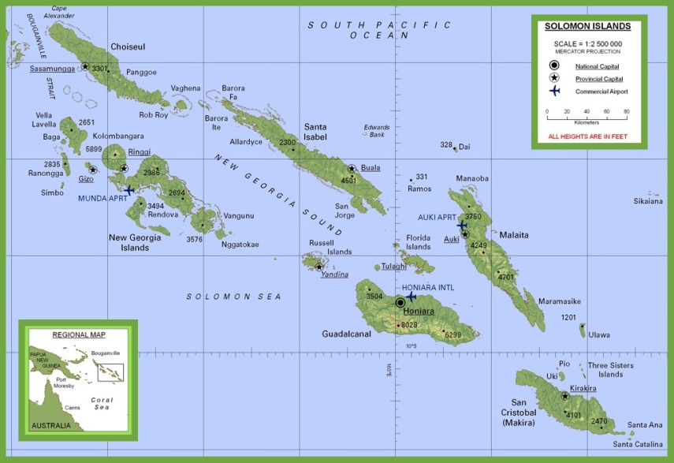
Why:
Japan – Building an airstrip on the island to control the region from the air. Holding the island would allow Japan to disrupt shipping lanes between North America and Australia. Cut Australia off from resources - effectively keeping Australia from being able to go on the offensive during the war. Air traffic to and from North America would be cut off. Sets Australia up for invasion.
United States – Japan continued to advance in the South Pacific. Taking Guadalcanal would halt the Japanese advance toward Australia. Victory would keep supply line to and from Australia open to the Americans.
Who won? Why?
The Americans won. Landed a significant force on the island. Captured and held Japanese airfield despite multiple attacks and bombings. They were able to get significant reinforcements and set up a strong defence. Attacked when Japanese became disorganized.
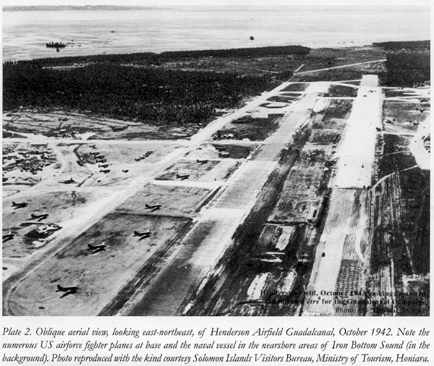
Japanese lost due to:
Continually on offensive – exhausted their soldiers.
Geography - Jungle terrain and the climate - hot temperatures and humidity adversely affected soldiers and equipment. Terrain hampered communications leading to often unorganized attacks.
Significance of Outcome:
First American land offensive against Japan.
Caught the Japanese off guard.
First American Victory on land against Japanese.
Americans control airspace and shipping lanes to Australia.
Japanese expansion in the South Pacific stopped.
Lessons Learned:
Battle showed the importance of proper supply lines (food, ammunition) and medicine.
Fighting in the tropics caused disease unfamiliar to the United States.
Japan – Approx. 14000 battle casualties, 9000 casualties due to disease and starvation
United States - Thousands disabled by illness i.e. Malaria

Sources:
C. N. Trueman, "The Battle of Guadalcanal," History Learning Site, last modified May 19, 2015, https://www.historylearningsite.co.uk/world-war-two/the-pacific-war-1941-to-1945/the-battle-of-guadalcanal.
"Solomon Islands Physical Map," World Maps | Maps of All Countries, Cities and Regions of The World, accessed December 11, 2021, https://ontheworldmap.com/solomon-islands/solomon-islands-physical-map.html.
"The Battle of Guadalcanal : Guadalcanal, Solomon Islands," Basecamp International, accessed December 11, 2021, https://www.guadalcanal.com/battleofguadalcanal.html.
Dave Homewood, "No. 1 and No. 2 (Islands) Works Sawmill Units, RNZAF," accessed December 11, 2021, https://www.cambridgeairforce.org.nz/RNZAF_Sawmills.html.
History.com Editors, "World War II Battles: Timeline," HISTORY, last modified May 5, 2021, https://www.history.com/topics/world-war-ii/battle-of-guadalcanal.

Bibliography

"The Battle of Guadalcanal : Guadalcanal, Solomon Islands." Basecamp International. Accessed December 11, 2021. https://www.guadalcanal.com/battleofguadalcanal.html.

History.com Editors. "World War II Battles: Timeline." HISTORY. Last modified May 5, 2021. https://www.history.com/topics/world-war-ii/battle-of-guadalcanal.

Homewood, Dave. "No. 1 and No. 2 (Islands) Works Sawmill Units, RNZAF." Accessed December 11, 2021. https://www.cambridgeairforce.org.nz/RNZAF_Sawmills.html.

"Solomon Islands Physical Map." World Maps | Maps of All Countries, Cities and Regions of The World. Accessed December 11, 2021. https://ontheworldmap.com/solomon-islands/solomon-islands-physical-map.html.

Trueman, C. N. "The Battle of Guadalcanal." History Learning Site. Last modified May 19, 2015. https://www.historylearningsite.co.uk/world-war-two/the-pacific-war-1941-to-1945/the-battle-of-guadalcanal.

.

