
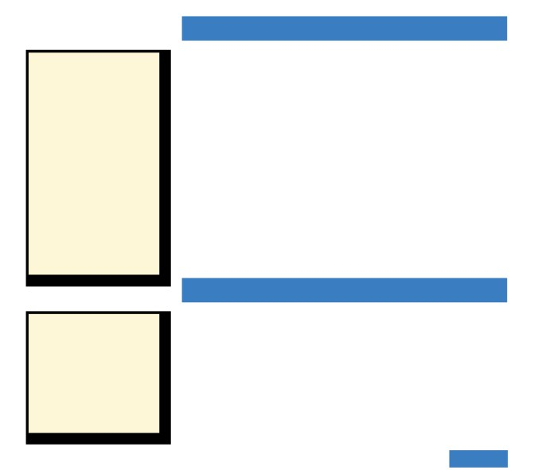

Chapter 3
Introducing Java

J

ava, developed by Sun Microsystems, is a widely used high-level

programming language. One reason for its wide-spread use is the ability to create platform-independent applications. This chapter introduces Java, OOP terminology, code conventions, and program design.

Why Program in Java?
Object-oriented programming (OOP) evolved out of the need to develop

The Gutenburg Press
About 1450, Johann Gutenburg
designed a system that used
cast metal letters and a printing
press where each of the
letters could be easily loaded
and then inked to make an
impression on paper. The key
to the Gutenburg press was
the reusable metal type that
could be reorganized over and
over again to inexpensively
create books and other printed
materials. The impact on
society was immeasureable as
people of every social standing
became literate.

Program Specification
A program specification is a
definition or outline of what
a program is expected to
do. In industry, a program
specification can serve as
a contract between the
programmer and the client.
complex programs in a systematic, modular approach. The OOP approach allows programmers to create modules that can be used over and over again in a variety of programs. These modules group related data and instructions for performing actions on that data. Properly designed, these modules encapsulate data to hide implementation details, are versatile enough to be extended through inheritance, and give the programmer options through polymorphism. Encapsulation, inheritance, and polymorphism are features of every object-oriented language, including Java.
In addition to being object-oriented, the Java language can be used to
create platform-independent applications. Platform-independent applications
can be run on any computer regardless of operating system or hardware
configuration. These features of Java have allowed programmers to cre-
ate programs for the masses—similar to the way the Gutenburg press
revolutionized the printing process, making printed materials available
to the masses.

Objects, Classes, and Packages
Object-oriented program development involves selecting objects to perform the tasks outlined in a program specification. An object consists of related data and the instructions for performing actions on that data. The design for an object is called a class. A class defines the type of data and actions that will be associated with an object of that class, but not the actual data for an individual object. Classes are required to create objects. Many objects of the same class may be needed in an application.

Chapter 3 Introducing Java 59

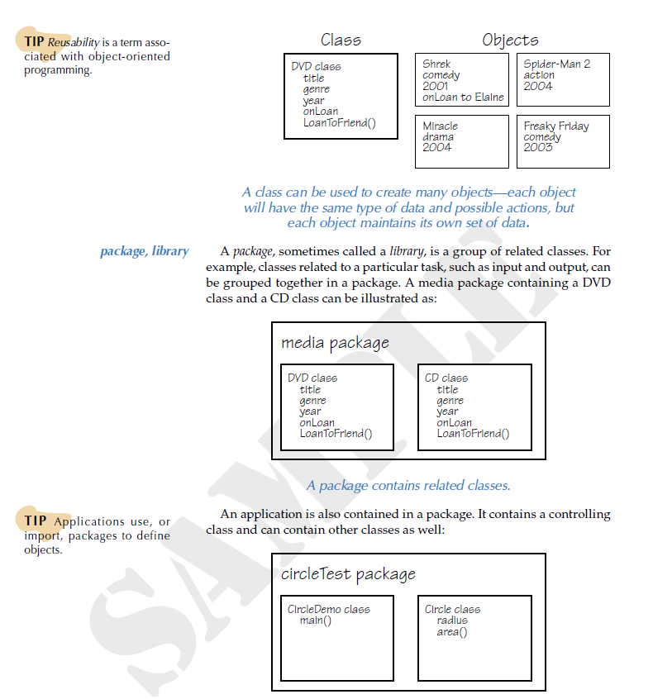
TIP Reusability is a term asso-
ciated with object-oriented
programming.

A class can be used to create many objects—each object will have the same type of data and possible actions, but
each object maintains its own set of data.

package, library

TIP Applications use, or
import, packages to define
objects.
A package, sometimes called a library, is a group of related classes. For example, classes related to a particular task, such as input and output, can be grouped together in a package. A media package containing a DVD class and a CD class can be illustrated as:

A package contains related classes.
An application is also contained in a package. It contains a controlling class and can contain other classes as well:

An application is contained in a package.
Packages are importable, which means an application can use existing classes from another package.

60 Chapter 3 Introducing Java


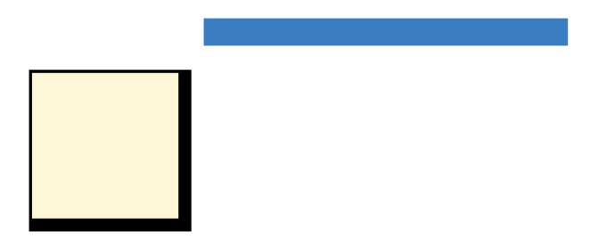

A Java Application
A Java application is a package with at least one class that contains a
main() method. The following Greeting application is a simple, yet com-

File Organization
Application development
requires careful organization.
Typically, the folder for an
application is given the same
name as the package name,
and the application name is
the same as the controlling
class name.

TIP The static void in the main() method means that it is a method of the class and does not generate a value.

statements

controlling class

method

comments
plete Java program:
/*
* Greeting.java
* A first Java application.
* A Student
* Course
* Date
*/

package firstApplication;

/**
* The Greeting class displays a greeting.
*/
public class Greeting { //start class definition

public static void main(String[] args) {
System.out.println("Hello, world!");
}

} //end class definition

Greeting generates output similar to:

A program consists of a set of instructions called statements. A semi-
colon is required to indicate the end of a statement. Related statements are enclosed by curly braces ({ }) to begin and end the instructions. The statements in the Greeting application are:
• package firstApplication declares a package name. If a package
name is not declared, then the application is given the package
name Default by the compiler. Simple applications often do not have package statements.
• public class Greeting is a class declaration. The class is available
to anyone (public) and is named Greeting. The Greeting class does
not define any data or actions for objects. However, it contains the main() method making it the application’s controlling class. The controlling class is a program’s starting point.
• public static void main(String[] args) defines the main() method.
A method is a named set of statements that perform a single, well-
defined task. The main() method is placed in the controlling class. Its statements are automatically run when the program is executed. The statement in this main() method uses the println() method to display “Hello, world!” to the system output (the screen).
In addition to statements, programs contain comments, which provide information about the program to the reader of the code. Comments have no affect on the program, but they allow a reader of the program to quickly understand the purpose and logic behind segments of code. Because complex applications are often developed and maintained by more than one programer, properly commented code allows for easier modifications and can decrease the number of mistakes.

Chapter 3 Introducing Java 61







Java programs can contain three types of comments:
• /* */ are used to enclose single or multiline comments. These
comments are appropriate at the beginning of a program to describe
the application and where necessary to clarify a segment of code.
• // are used for adding a comment to the end of a statement or to
create a single line comment. The // is also useful for debugging
a program, which will be discussed in a later chapter.
• /** */ are used for documentation. The javadoc tool copies
these comments into a separate HTML document to create an
instructional manual or external documentation. Documentation
comments are appropriate for describing a class or method.

TIP The main() method does
not typically have a comment
block.

TIP Visit lpdatafiles.com for specific information about dif-
ferent Java compilers.

Platform-Dependent
Programming languages such
as C++ and Visual Basic
.NET are compiled directly to
machine language. Although
faster, these programs must be
recompiled for every platform
that will run the application.

Virtual Machine
Virtual means not real. A
virtual machine is therefore
conceptual, not made of
hardware and other physical
components.

Review:HelloWorld
Multiline comments that describe a program, class, or method are some-
times referred to as a comment block. Tips throughout the text will provide additional pointers about commenting code.

Executing a Java Application
Java code typed by a programmer is called source code. For source code to execute, or run, it must be translated to code the computer understands in a process called compiling. Many Java compilers provide an environ-
ment for entering the source code as well as for compiling and running an application. Source code files have the extension .java, while compiled files have the extension .class.
Compiled Java source code is called bytecode. Executing a Java applica-
tion means that its bytecode is interpreted with a Java Virtual Machine (Java VM). The interpreter runs each bytecode instruction as it is read. The Java VM can reside on any computer, regardless of operating system environment, making Java applications extremely portable, reliable, and platform-independent.
Although bytecode is versatile for porting applications to several dif-
ferent environments, programs compiled to machine code run faster. Machine code is comprised of just 1s and 0s and is different depending on the computer platform. A just-in-time compiler (JIT) converts bytecode to machine code before it is executed with the Java VM.
A program containing syntax errors will not compile. A syntax error occurs in a statement that violates the rules of Java. For example, all Java statements must end with a semicolon. A statement without a semicolon generates a syntax error when the program is compiled, preventing the compiler from generating bytecode for the application.

Create the HelloWord program as discussed by Mr. Bennett.

62 Chapter 3 Introducing Java

Displaying Output

output stream

print() println()

TIP The System class is in the java.lang package.

argument

string

escape sequence
An output stream sends data to an output device. To process data for the
output stream, Java provides the System class with methods for display-
ing output. For displaying data to the standard output stream, which is
typically the computer screen, use System.out. out contains print() and
println() methods. The difference between these methods is how they
control output. The print() method displays data and leaves the insertion
point at the end of the output, while println() moves the insertion point to
the next line after displaying output. The following application uses both
methods:
/**
* Displays a welcome message.
*/
public class MulticulturalGreeting {

public static void main(String[] args) {
System.out.print("Hello");
System.out.print("Buenos Dias");
System.out.println("Bonjour");
System.out.println("How do you greet another?");
}
}
The print() and println() methods require arguments. An argument is data passed to a method for processing. In this case, the print() and println() arguments are strings. A string is a set of characters, which are enclosed by quotation marks.
MulticulturalGreeting produces output similar to:

An escape sequence is a backslash (\) followed by a symbol that together represent a character. Escape sequences are used to display special char-
acters. Common escape sequences include:
\n newline
\t tab (8 spaces) \\ backslash
\" double quotation mark
The modified MulticulturalGreeting illustrates the use of escape sequences:
/**
* Displays a welcome message.
*/
public class MulticulturalGreeting {

public static void main(String[] args) {
System.out.print("Hello\t");
System.out.print("Buenos Dias\t"); System.out.println("Bonjour");
System.out.println("How do you greet another?");
}
}

Chapter 3 Introducing Java 63


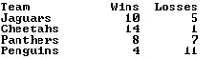
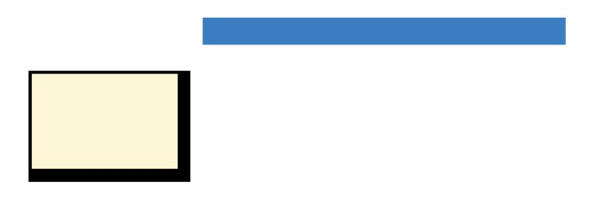


Review: AboutMe - part 1 of 2
Create an AboutMe application that displays your first name and last initial, your instructor‘s name, and
your school name on three separate lines. Below the personal information, display a phrase that encourages
your school team. For example, “Go Bears!” Be sure the phrase is displayed with quotation marks.

Formatting Output
The format() method can be used in place of the print() or println()
methods to control the way output is displayed. The format() method

Numeric Output
The NumberFormat class,
discussed in Chapter 4, can
also be used to format numeric
data.

TIP The format() method is
new to Java 5 and requires
JDK 5.
arguments include a format string and an argument list. The format string contains specifiers that indicate how the corresponding strings in the argument list should be displayed. The following code demonstrates the format() method:
System.out.format("%-10s %8s %8s", "Team", "Wins", "Losses\n"); System.out.format("%-10s %8s %8s", "Jaguars", "10", "5\n");
System.out.format("%-10s %8s %8s", "Cheetahs", "14", "1\n");
System.out.format("%-10s %8s %8s", "Panthers", "8", "7\n");
System.out.format("%-10s %8s %8s", "Penguins", "4", "11\n");

When executed, the statements display:

A format string specifier takes the form:
%[alignment][width]s
% indicates the start of a specifier
[alignment] skip for right alignment.
Include a minus sign (-) for left alignment
[width] the number of characters to use for output
s indicates that the corresponding argument is a string

If [width] is greater than the number of characters in the corresponding string argument, then spaces pad the output. A string longer than [width] characters is displayed, but any strings to the right are moved over.
Text may also be included within the format string. For example, the statement:
System.out.format("The final game score: %-8s %8s", "10", "5");
displays:

64 Chapter 3 Introducing Java

Review: AboutMe - part 2 of 2
Modify the AboutMe application to include your class schedule, the days of the week that your class meets, and the start and end time of each class. Include code to properly align the data into three columns with the weekdays left aligned and the class start and end times right-aligned.

Code Conventions
Code conventions are a set of guidelines for writing an application. These guidelines provide details about commenting, rules for naming methods, classes, and packages, and statement formatting. Just as comments inform a reader about a segment of code, a program that follows specific code conventions is easier to read and understand.
A company or organization that employs programmers will typically
adhere to specific code conventions. A programmer familiar with the
code conventions will more quickly become familiar with code written
by another programmer in the company. Code conventions can make
modifying and maintaining code faster, easier, and less expensive. Because
of these benefits, organizations often not only encourage the use of code
conventions, but require it.

TIP Code conventions are
important. About 80% of the
lifetime cost of a piece of soft-
ware goes to maintenance.
Rarely is software maintained
for its whole life by the original
author.
The code conventions introduced in this chapter are:
• An introductory comment should begin a program. This comment
should include information such as your name, class name, the
date, and a brief statement about the program.
• Package names should begin with a lowercase letter and then an
uppercase letter should begin each word within the name. Package
names may not contain spaces.
• Class names should be nouns and begin with an uppercase letter
and an uppercase letter should begin each word within the name.
Class names may not contain spaces.
• A comment block should be included before each class and
method. A comment block is not typically placed before the main()
method.
• Comments should not reiterate what is clear from the code.
• Statements in a method should be indented.
• An open curly brace ({) should be placed on the same line as
the class or method declaration, and the closing curly brace (})
should be on a separate line and aligned with the class or method declaration.

Chapter 3 Introducing Java 65

Algorithm Design
Programs are created to solve problems. However, problems of any complexity require outlining, or designing, a solution before typing any source code. One method of design is called an algorithm. An algorithm is a set of steps that outline how to solve a problem.
Algorithms can be created in several ways. Often more than one
approach is implemented. Steps written out in plain English is one
pseudocode approach. Pseudocode is a mix of English and program code, and is useful
flowcharts for refining a plain English algorithm. Flowcharts use symbols and text to
give a visual representation of a solution.
A description of the problem to be solved is used in developing an algorithm. For example, a program specification may state “The Triangle application displays a right triangle made up of the asterisk (*) symbol. The triangle should be 4 asterisks high by 4 asterisks wide.” Triangle appears to be a very simple application. From the description, we conclude that Triangle should display an image of a right triangle.
The next step after analyzing the problem is to produce the algorithm. In
most cases, use more than one method to generate the algorithm to ensure
that the solution to the problem is accurate. The following illustrates the
Triangle program in both plain English steps and a flowchart:
The Triangle algorithm in plain English:
1. Print an asterisk to the screen.
2. Print two asterisks to the screen.
3. Print an asterisk followed by a space and an asterisk to the
screen.
4. Print four asterisks to the screen. The Triangle flowchart:

66 Chapter 3 Introducing Java

