Tutorial No. 2 Maya Basics-How to Build a Lamp
1. From the main menu go to the bottom of the menu and ensure ‘Interactive Creation’ is checked. Then choose create Polygon Primitives-Cylinder settings box.
A. On the right side of the screen you'll see the Polygon Cylinder attributes panel. Set Axis Divisions to 6 and Height Divisions to 12 (see below).
B. Go to the middle of the stage Left Click and drag to produce the base of your cylinder. Next, click on the base of your cylinder and drag upward to give your cylinder height (your cylinder should look similar to the one below).
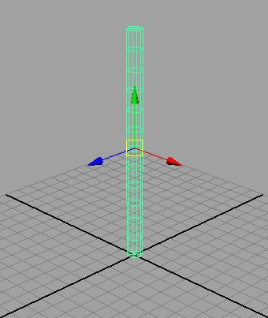

Making the Base
2. Right-Click on object and hold-drag to vertex mode. Drag select the bottom ring of vertices. Press the ‘R’ key to select the scale tool. Left mouse the yellow box to scale the vertices larger.
3. Select the next set of vertices above the last selected row. ‘W’ key for move tool. Select the green arrow and drag down to make the base thinner. (See image below)
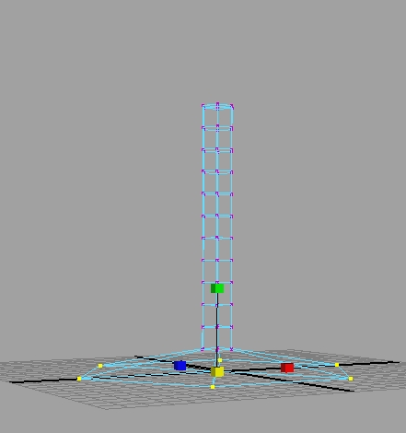

Making the Shade
4. Select the top four rows of vertices. With the ‘W’ key use the green arrow (y-axis) to move upwards a fair distance from the remainder rings of vertices. See example below. Do it again with just the top two set of verticies (move it only about half as far).
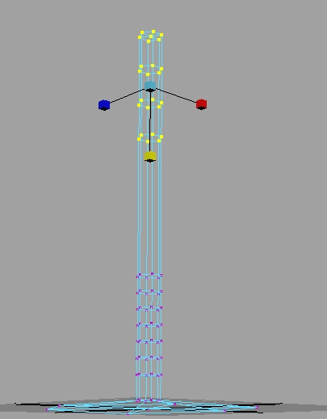

5. Select the second set of vertices from the top and using the scale tool ‘R’ scale outward using the middle box. The shade should approximately be as wide as the base. Using the ‘W’ key grab the top set of vertices and move down into the previous expanded set.
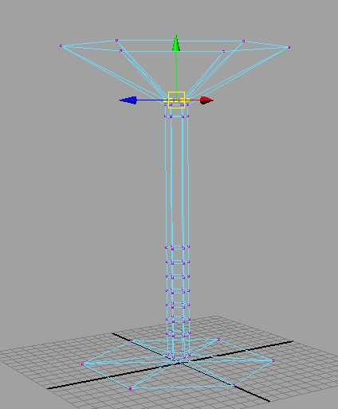

Making the Ornamentals

6. With the ‘W’ key (move tool) select five rings of vertices and using the green arrow (Y-axis) move them upwards so that the middle ring is in the middle of our lamp stem. Select the middle ringlet of vertices and scale (R key) using the middle box. See example. Afterwards select all of the moved five rings of vertices and scale them narrower and tighter in the Y-axis. Having additional geometry near the middle part will help the look when we finally smooth the object, but first…
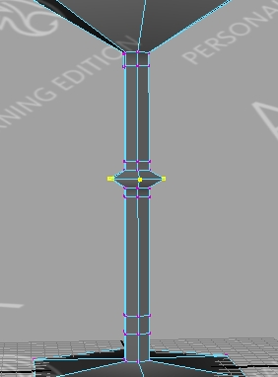

Applying Materials

7. Go into faces mode, ‘Right-Click, face.’ Then drag selecting the bottom half, avoiding the middle ornament part. See below. Right-Click on the object and select ‘assign new material, phong.’
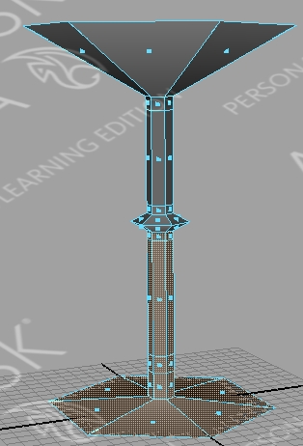
8. This will bring up the attributes panel with the phong material. Under the colour attribute select the box next to ‘Color’. This will bring up a colour selector. Pick a metallic colour. Choose something similar to gold, bronze or silver. Hit accept when you have chosen your colour.
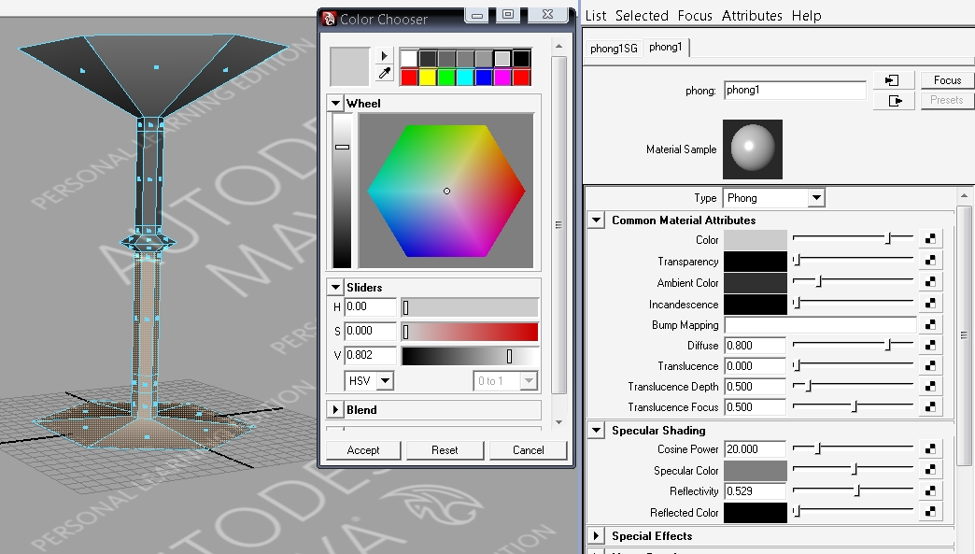

Shade Material

9. Select the faces of the upper stem above the ornamental middle part and below the shade. Right-Click on the object and select, ‘assign existing material, phong1.’ This will apply the already existing material you created in the last step.
10. Moving onto the shade now, select the shades’ faces and ensure you’re careful by going into wireframe mode (four on the keyboard) and don’t select any other but the shade’s faces.
11. Now with the shade selected, Right-Click and ‘assign new materials, phong E.’ Choose a glassy colour that will suit your model’s overall look.
12. Within the Attributes window make you’re attributes approximately to mine, as seen in the example below.
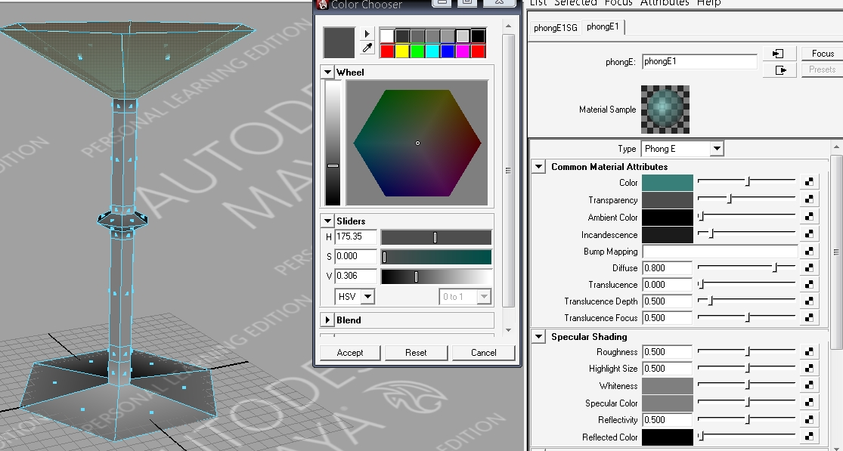

Ornamental Material
13. Carefully select the ornamental faces and Right-Click and apply the same material as the shade.
14. Right-Click on object and go into ‘object mode’
15. Select entire object.
16. From main menu, select ‘Mesh, Smooth.’ Do it again for a second smooth. Not more than twice, it might look too ‘doughy’ and not enough is still too rigid and polygonal. Two is good.
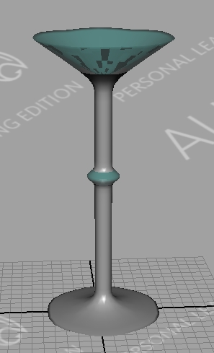

Light Bulb
17. Main menu, create, sphere options box. In the divisions choose 10 and 11.
18. In vertex mode, select the bottom four rings of the sphere. Ensure in wireframe mode that you don’t have anything unnecessary selected. See example.
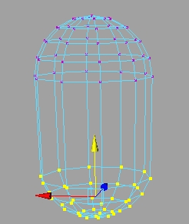
19. Select the bottom two and move them down using the move tool. Using the fourth ring from the bottom and scale it down so it cinches. See example.
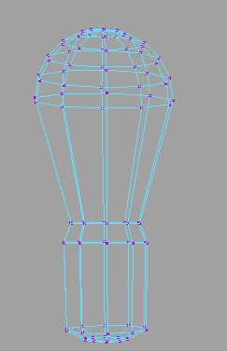

20. Select the whole top half and scale out using the middle yellow box. See screen shot.
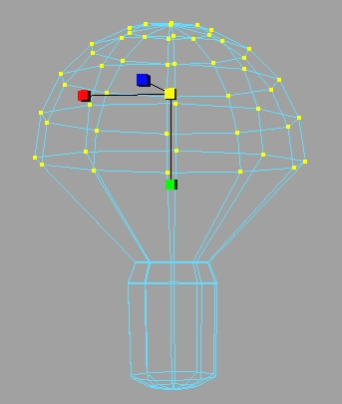

Applying Materials To Lightbulb

21. Right-Click the object and drag to ‘Face’. Select the bottom part of the lightbulb. See screenshot. Be sure to Right-Click and assign new materials Phong. Make the colour metallic or brassy. Hit accept.
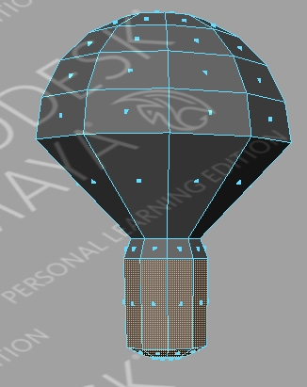
22. Select the top half of the bulb in face mode. Assign a new material, phong E. Make it mostly white with a tint of yellow.
23. For the rest of the attributes, make Colour, Transparency, Ambient Colour, and Incandescence similar to the picture below.
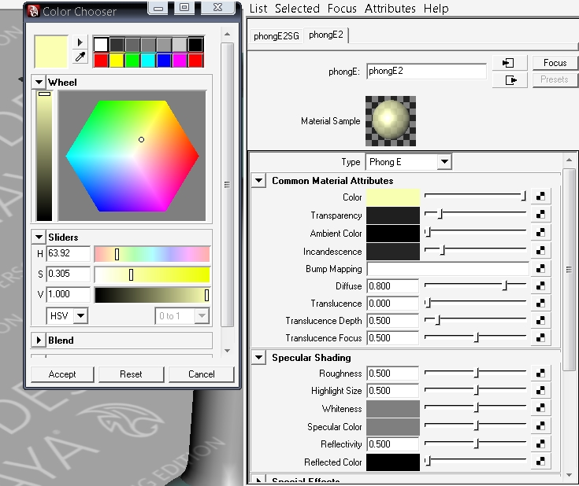

Finish Line
24. Right-Click and drag to ‘Object’ mode. Ensure the entire object is selected. From the main menu go to ‘Mesh - Smooth’. Repeat the smooth function for a total of two times.
25. In object mode use the move tool (‘W’ key) to move the bulb into the lamp. Scale to the size necessary for it to fit the lamp without looking goofy. See example.
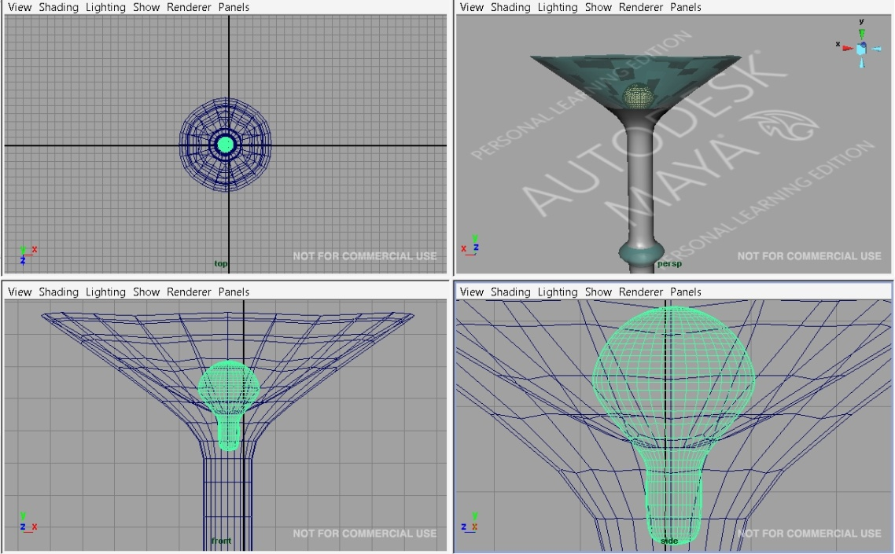
26. Select both objects. From the main menu select ‘Mesh – Combine’.
27. Get into a good perspective view and hit the render box. The right hand upper portion for the screen, there is a black and white movie thing also known as a ‘clapper’. Click on that to render the current frame (ensure the Maya Software is selected in the Render View drop down list).
