Maya Tutorial 4: Animating Rocket Ship:

Planet Creation and Node Hierarchy:
- Create a Sphere off to the side of your rocket. The Sphere is going to represent a planet. (See image below). Apply an appropriate material to your planet.
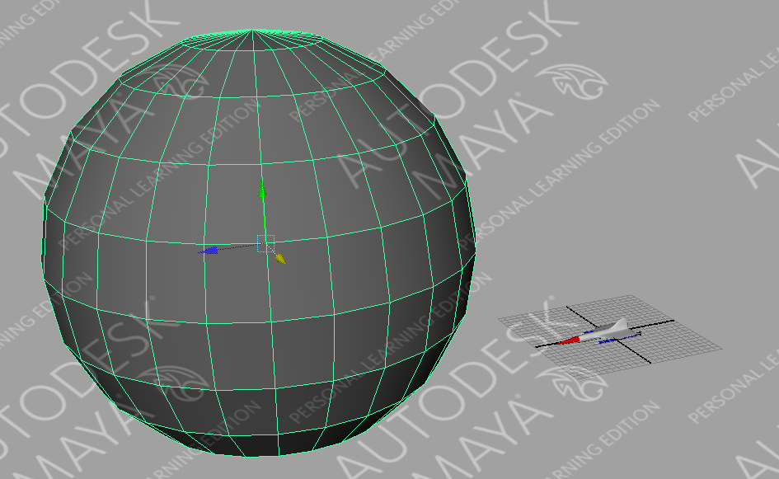
- Click the ‘Perspective Outliner’ from the toolbox on the left side of the screen.
  - Select ‘PolySurface1’ and rename it ‘Rocket_Body’.

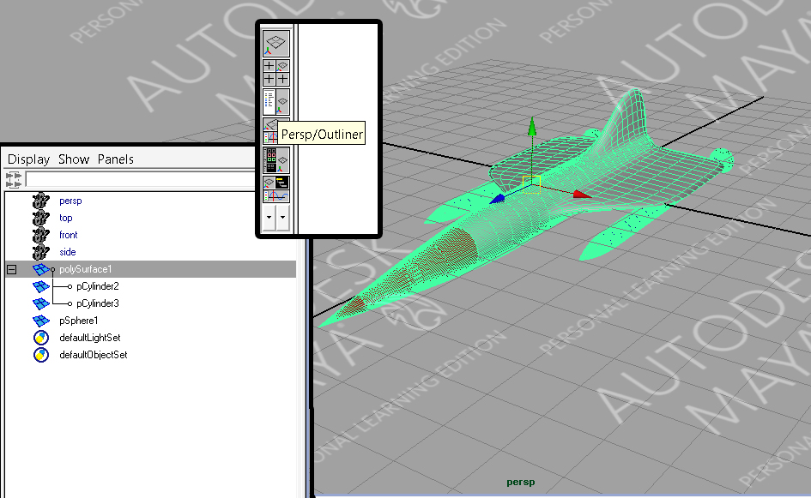

  - Rename the other objects as per image below.
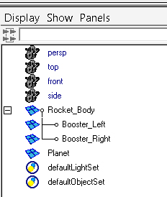
- Ensure ‘Rocket_Body is selected.
  - Ctrl-G (This will create a group of objects)
  - Rename the group Rocket_GRP (See image below).
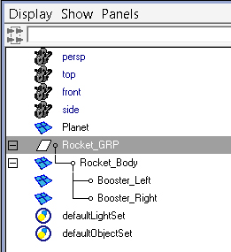

Curve Creation
- Select the ‘Four View’ button from the toolbox on the left side of the screen.
  - Click in the ‘Top View’ and then hit the spacebar in order to maximize this view.
- From the Shortcut bar above the window select the ‘Curves/Surfaces’ tab.
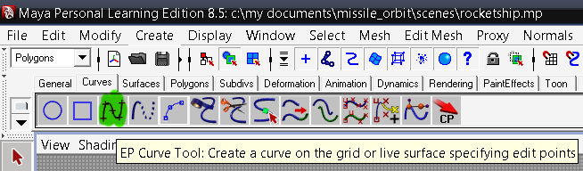
  - Select the ‘EP Curve Tool’. (See image below)

- Use the ‘EP Curve Tool’ to create a spiral around the sphere. Do not use too many points as it will become very hard to edit if problems arise. (See image below).
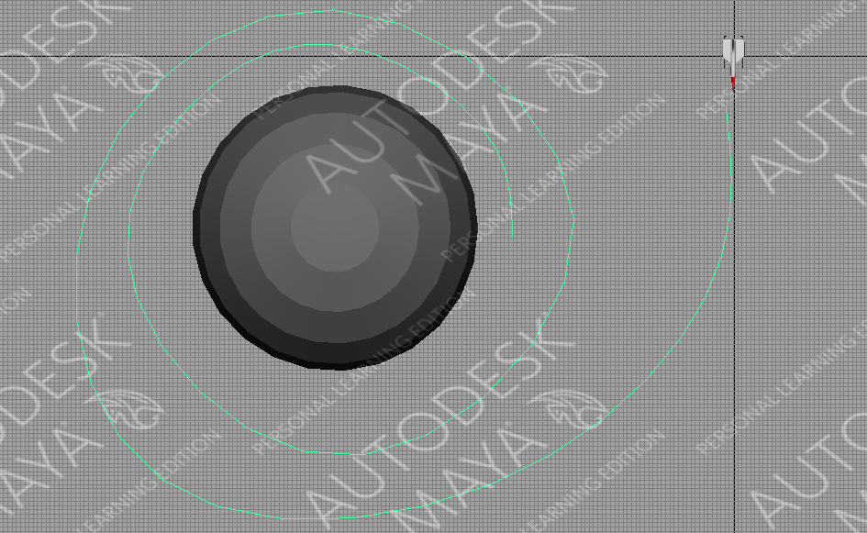
- Hold down ‘Spacebar - Right_Click – Persepctive View
  - Right_Click on the curve choose ‘Control Vertex’. (This will show the vertices of the curve so that you can manipulate it.)(See image below).
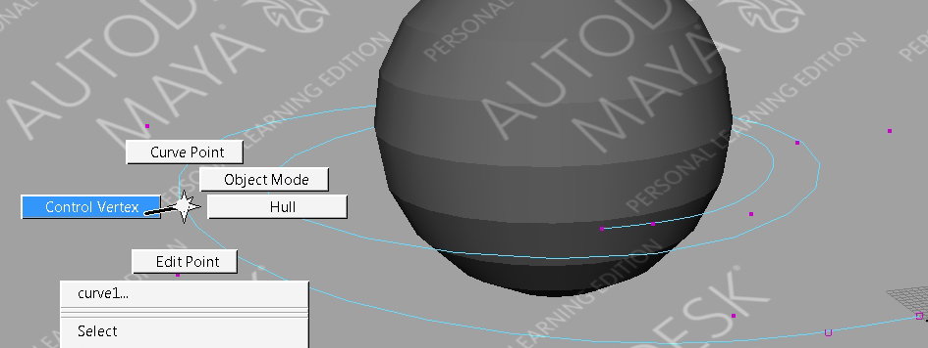
- Select some of the vertices and use your ‘Move Tool’ to position them similar to the image below.
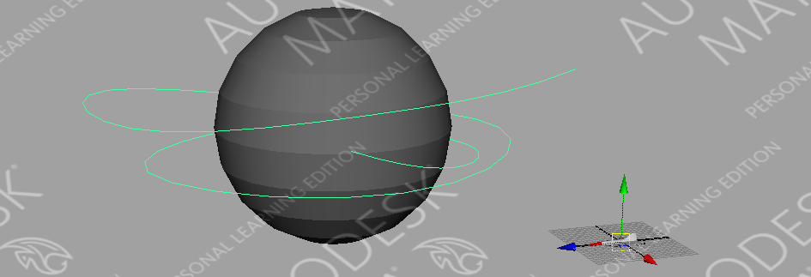
- Click the ‘Perspective Outliner’ from the toolbox on the left side of the screen.
  - Rename ‘curve1’ to ‘Orbit_Curve’. (See image below).
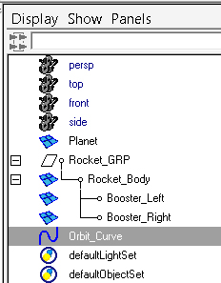

Attaching to Motion Path
- Select ‘Rocket_GRP’ and ‘Ctrl – Orbit-Curve’.
- Just below ‘File’ of the main menu is a dropdown menu. From the dropdown menu select ‘Animation’.
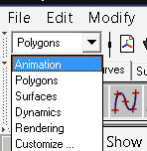
  - Main Menu – Constrain – Motion Paths – Attach to Motion Path option box
  - Set the motion path options as per the image below.
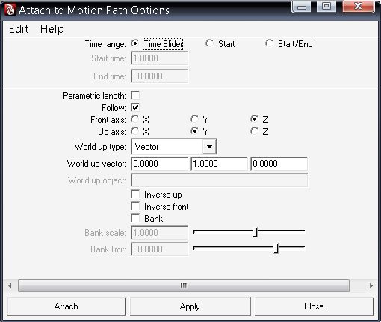
  - Select the Attach or Apply buttons. Your Rocket should attach itself to the curve. (See image below)
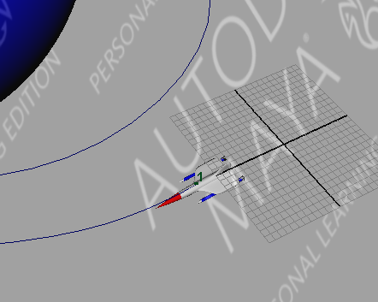
  - Use the black slider at the bottom of the screen to view your rocket orbiting your planet.

Edit Animation Curve
- From the main menu select ‘Display-Workspace-Animation’

- Select ‘Rocket_Group’ (See image below) in the Graph Editor Window
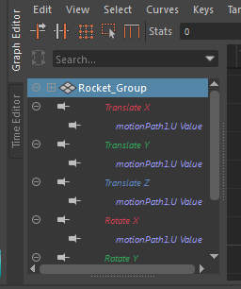

  - Move mouse to the graph (do not click in the graph) and press the ‘F key’. This will Frame the animation curve. (See image below)
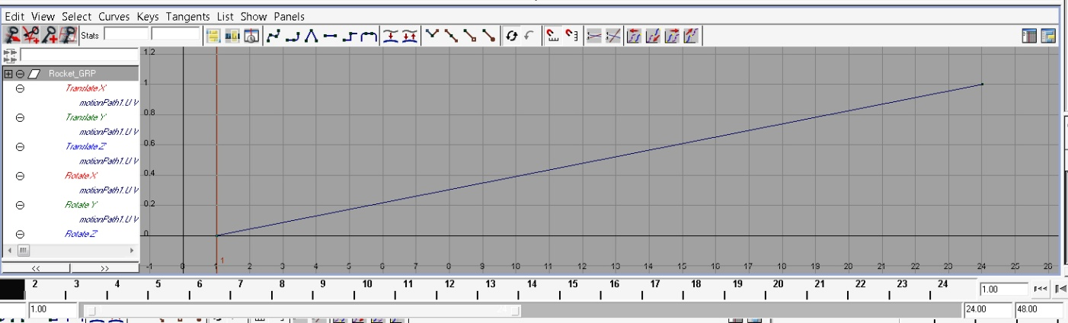
  - Drag select the entire curve to ensure you have both endpoints.

- Select the ‘Flat Tangents’ button from the shortcut bar above the graph. This will ease the animation in for you. (See image below)
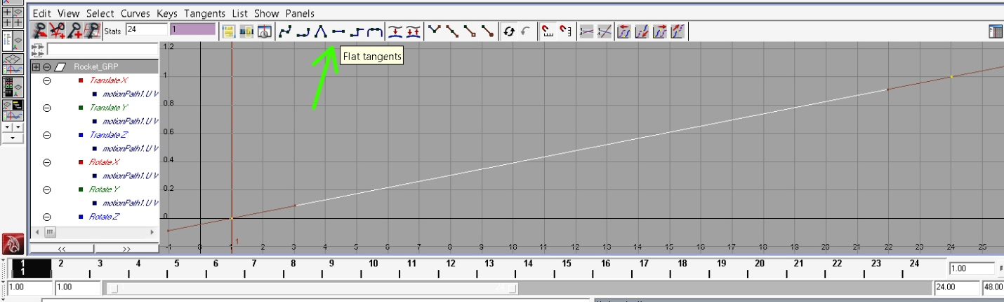

- Select on the right side endpoint of the curve. (See image below).
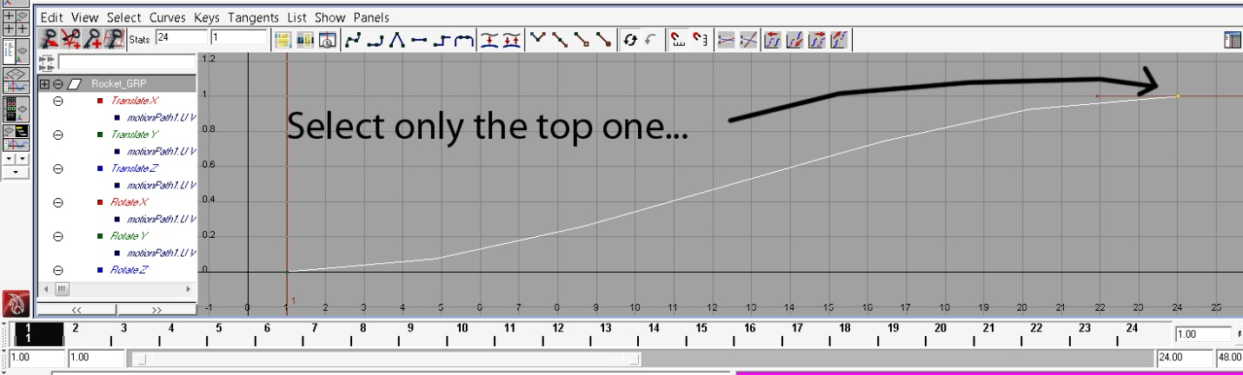
- Hold down ‘Alt’ button – Right_Click and drag left to zoom out the graph.
- Above the graph change the frame number 24fps to 375fps. This will now expand the animation to 375 frames. (The end point of the curve will automatically move there.) (See image below). 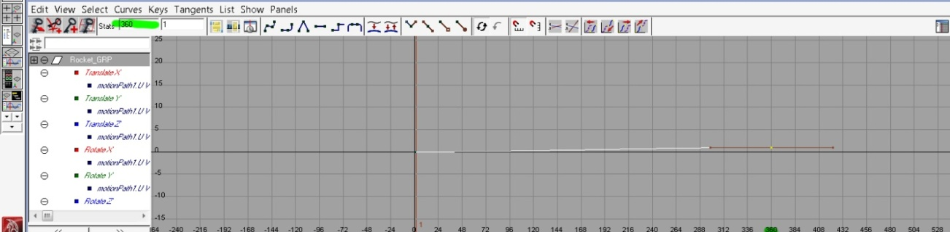

- In the bottom right corner, change the number 24 to 360. This will allow us to view our animation up to 360 frames. (See image below).
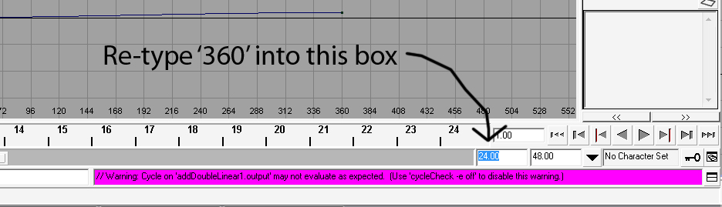
- Press the play button at the bottom right of the screen to watch your animation.

Export Animation
- From the Main Menu Selection List select ‘Rendering’.
- From the shortcut toolbar at the top of the screen select the ‘Clapper with the two dots’. This is the ‘Render Settings’.
  - Ensure settings match the image below.
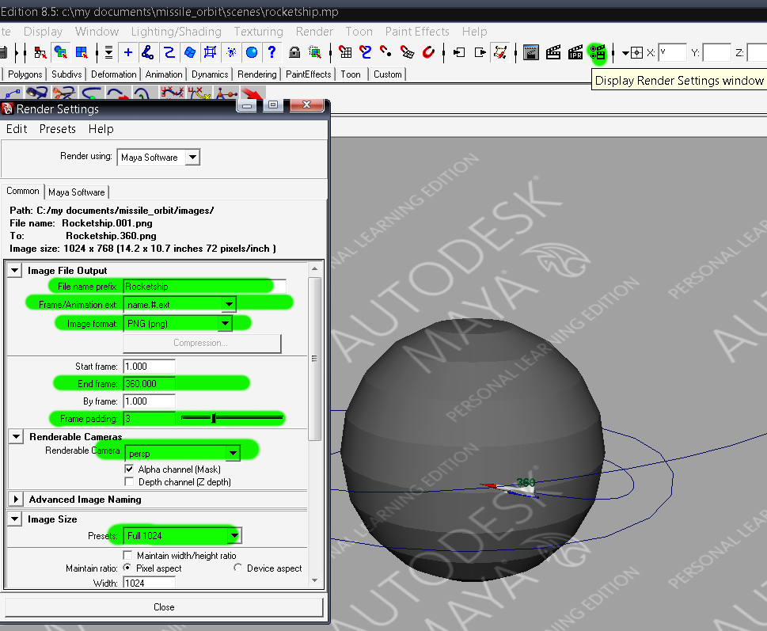
- Position you camera so that the scene is in a position you would like to view when exported. (See image below)
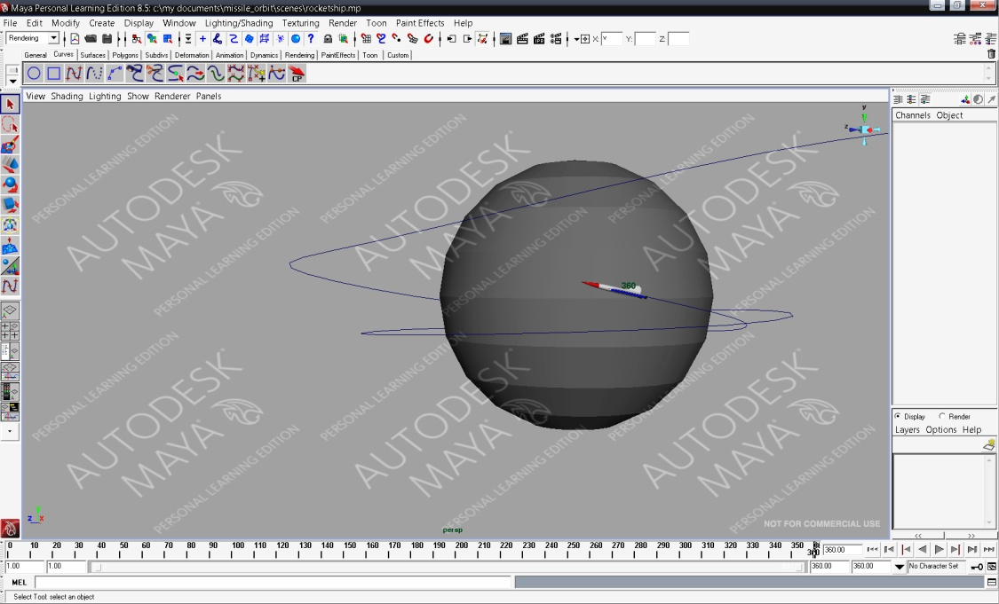
- From the main menu select ‘File – Poject - Set Project’
  - Save the new project in an appropriate folder. Name the project ‘Rocket_Ship’
  - Main menu – Render – Render Settings. Under ‘File Output’ change the ‘Image format’ to PNG. Then under ‘Frame/Animation ext:’ choose any format that does not have ‘Single Frame’ after it.
  - Main menu – Render – Batch Render (This will export each frame of your animation as a .png to the ‘images’ folder found inside your ‘Rocket_Ship’ project folder.) This will take a while.

Import to Adobe Premiere
- Select ‘New Project’.
  - Click on the ‘DV-24P’ and select ‘Standard 32KHz.

    - At the bottom of the screen select and appropriate save folder on your H:drive and name the animation ‘RocketAnimation_yourname’.
- Select ‘File – Import’. Browse to the ‘images’ inside you ‘Rocket_Ship’ project folder. This should contain all of the individual exported images from your animation.
  - Click on RocketShip.001.png and ensure you check the ‘Numbered Stills’ box at the bottom of the dialogue box. Click ‘OK’
  - Rocketship.001.png will show up near the top left of the screen.
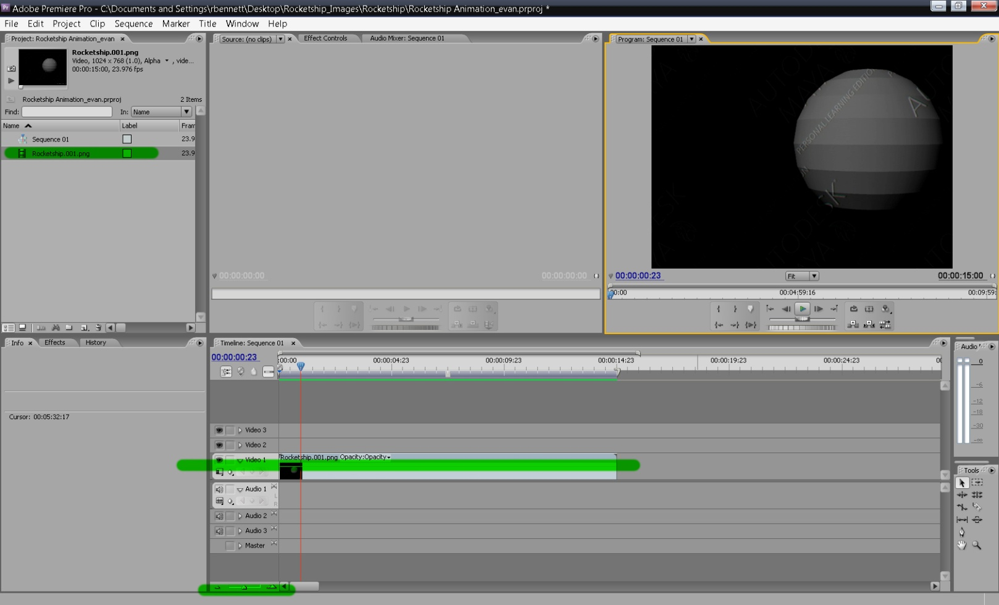
    - Drag Rocketship.001.png to the Video 1 layer of the timeline. (See image below).

- Select ‘File – Export’. Save the animation as RocketshipAnimation_yourname.avi. Premier will now render your movie. Save it in an appropriate folder.
- Locate file and watch your movie.

