Exercises

Exercise 1 ——————————————————————— House Create a House application that calls methods addRoof(), addBase(), and addWalk() to display the following:

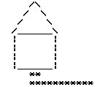

Exercise 2 ————————————————— MetricConversion
The following formulas can be used to convert English units of measurements to metric units:

inches * 2.54 = centimeters feet * 30 = centimeters yards * 0.91 = meters
miles * 1.6 = kilometers
Create a MetricConversion application that displays a menu of conversion choices and then prompts the user to choose a conversion. Conversion choices should include inches to centimeters, feet to cen- timeters, yards to meters, miles to kilometers, and vice versa. The application should include separate methods for doing each of the conversions. Application output should look similar to:

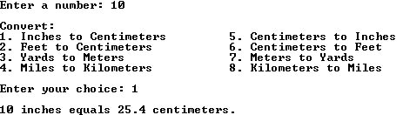

Exercise 3 ———————————————————— IsoTriangle Create an IsoTriangle application that prompts the user for the size of an isosceles triangle and then displays the triangle with that many lines. The IsoTriangle application code should include:

• the drawBar() method from the chapter.
• An addSpaces() method which “prints” spaces. Application output should look similar to:

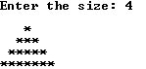

Exercise 4 ————————————————————— AddCoins Create an AddCoins application that prompts the user for the number of pennies, nickels, dimes, and quarters, and then displays their total dollar amount. The AddCoins application should include
a getDollarAmount() method that has four int parameters corresponding to the number of pennies,
nickels, dimes, and quarters, and returns a String that corresponds to the dollar value of the coins.
Note that the String returned should include the currency sign ($). Application output should look
similar to:

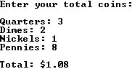

Exercise 5 ————————————————— PythagoreanTriple Create a PythagoreanTriple application that displays all pythagorean triples with values of A and B less than 100. A pythagorean triple is a set of three integers that make the equation a2 + b2 = c2 true.
The application should include a PerfectSquare() method that uses the solution from the PerfectSquare
review in Chapter 6. (Hint: You will need to generate all possible combinations of A and B and display
just those that work.)

Exercise 6 ———————————————————PerfectIntegers Create a PerfectIntegers application that displays all perfect integers up to 100. A perfect integer is a number which is equal to the sum of all its factors except itself. For example, 6 is a perfect number
because 1 + 2 + 3 = 6. The application should include a boolean method isPerfect().

Exercise 7 ———————————————————————— HiLo
a) In the Hi-Lo game, the player begins with a score of 1000. The player is prompted for the number of points to risk and a second prompt asks the player to choose either High or Low. The player’s choice of either High or Low is compared to random number between
1 and 13, inclusive. If the number is between 1 and 6 inclusive, then it is considered “low”. A number between 8 and 13 inclusive is “high”. The number 7 is neither high nor low, and the player loses the points at risk. If the player had guessed correctly, the points at risk are doubled and added to the total points. For a wrong choice, the player loses the points at risk. Create a HiLo application based on this specification. Application output should look similar to:

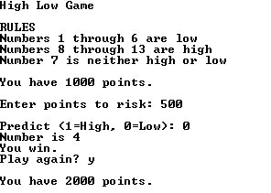

b) Modify the application to allow the player to continue until there are 0 points left. At the end of the game, display the number of guesses the user took before running out of points.

Exercise 8 ———————————————————————— Nim The game of Nim starts with a random number of stones between 15 and 30. Two players alternate turns and on each turn may take either 1, 2, or 3 stones from the pile. The player forced to take the last
stone loses. Create a Nim application that allows the user to play against the computer. In this version
of the game, the application generates the number of stones to begin with, the number of stones the
computer takes, and the user goes first. The Nim application code should:

• prevent the user and the computer from taking an illegal number of stones. For example, neither should be allowed to take three stones when there are only 1 or 2 left.
• include an isValidEntry() method to check user input.
• include a drawStones() method that generates a random number from 1 to 3 for the number of stones the computer draws.
• include separate methods to handle the user’s turn and the computer’s turn. Application output should look similar to that shown on the next page:

