Anatomy & Physiology 12
Circulation System Lab

Part A Blood
- Observe the example of a prepared blood slide below.

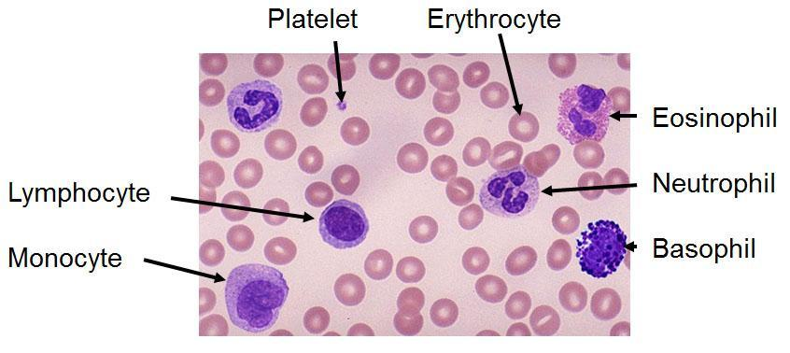
- Count the number of red blood cells, white blood cells and platelets you see in the image. Record your numbers in the table below. Look up and record the size of each of the formed elements, and identify which contain a nucleus and which do not.

Formed Element | Number in Field of View | Approximate Size (µm) | Presence of a Nucleus
Red Blood Cell
White Blood Cell
Platelet

- Research how many white blood cells are normally found in a sample of blood from a healthy person (recorded as 1 WBC per X RBC). How does this number compare with the image above? What does this suggest about the person whose blood is shown in the above image?

Part B Heartbeat
- Sit on a chair, close your eyes and take relaxing breaths for 1-2 minutes. Find your radial pulse on the outside (thumb side) of the wrist. Determine your heart rate by count the number of pulses in 15 seconds, and then multiply this number by 4. Record this number below.

Pulse rate =

- Run in place, perform jumping jacks, or do another similar type of exercise for 2 minutes. At the end of 2 minutes of exercise, measure and record your pulse.

Pulse rate after exercise =
- Repeat the exercises you did for part 2 to achieve roughly the same heart rate. After 2 minutes, sit back down and relax. Measure and record your pulse rate after 1 minute and after 2 minutes.

Pulse rate after 1 minute =

Pulse rate after 2 minutes =

Part C Electrocardiogram (ECG)
- Observe the following print out of a normal electrocardiogram (ECG). What causes the P wave? What part of the hear is this acting upon and what does that part do? What causes the QRS wave, and what is the result of this?

P wave caused by:

Part of the heart acted upon:

What this part does:

- What causes the QRS wave? What part of the hear is this acting upon and what does that part do?

QRS wave caused by:

Part of the heart acted upon:

What this part does:

R
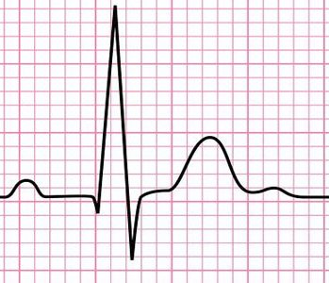
ϴ
S
End of heartbeat
Start of heartbeat
T
Q
P
C
A
B

- Each square on an ECG measures 0.04 seconds. The thick lines at the bottom indicate the start/stop points for each of the three wave portions. Calculate the time for:

Start of P wave to start of QRS wave (A)

QRS wave (B)

End of QRS wave to end of T wave (C)

Total time for one heart beat

- There is a 0.12 second pause between the end of the P wave hump and the start of the QRS wave (section ϴ on the graph). Taking into consideration what is actually happening with the heart during these times, why is the pause necessary for proper functioning of the heart?

