Maya - Teapot Tutorial
- From the main menu choose ‘Create-Polygon Primitives: check the Interactive Creation option box’
- From the main menu choose ‘Create-Polygon Primitives-Sphere option box’. Set height divisions to 10.
- Hold down Shift-Key. Drag on the grid until sphere is the appropriate size. See the picture below.
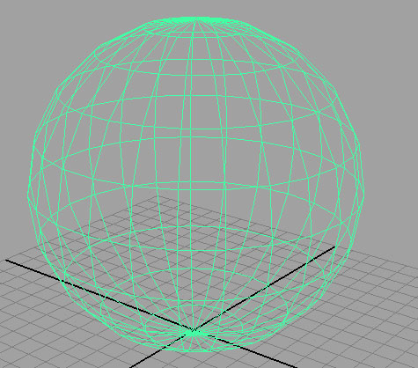
- Press the Spacebar. This will show the object from four different views. Select the side view. Press the spacebar again to expand it in the window.
- Right-Click the object and drag to Vertex . Your object is now in vertex mode where it can be edited at each individual point where the lines meet. Vertex intersections are purple dots.
- Select the five middle sets of vertices. Press the ‘R” key to select the scale tool. Next drag the middle of yellow box away from center as per the image below.
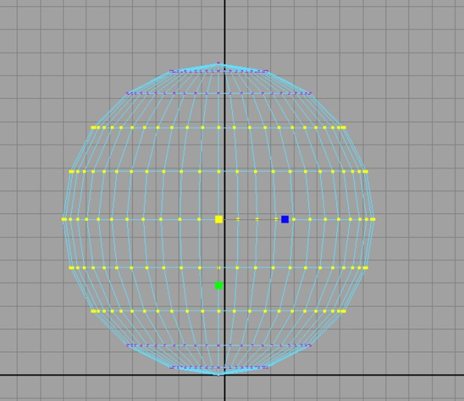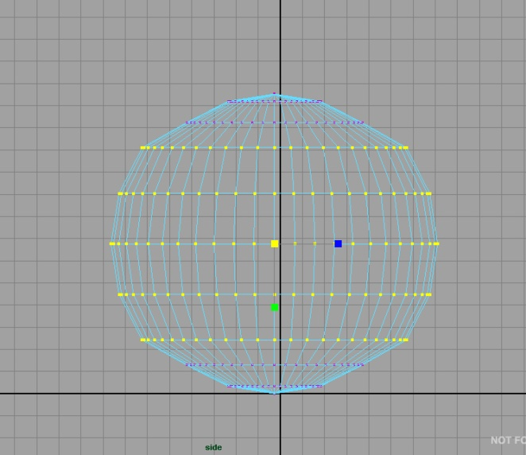
- Hold Ctrl-Left Click and drag a box over the top row of the selected vertices. This will deselect that row.

- Scale again dragging on the yellow box and away from the center. See image below.
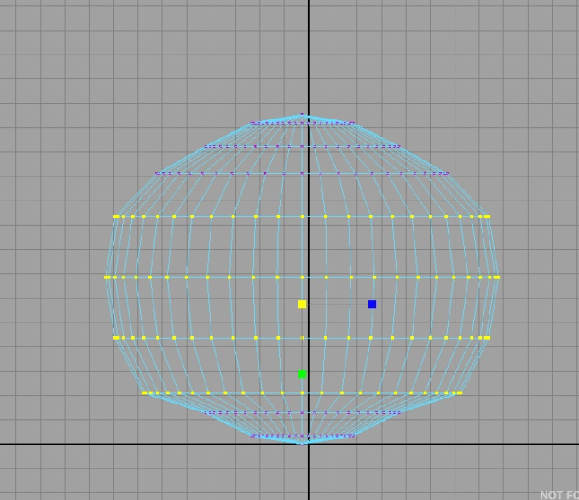
- Once again hold Ctrl-Left Click and drag a box over the top row of the selected vertices. This will deselect that row.
- Scale again dragging on the yellow box and away from the center. See image below.
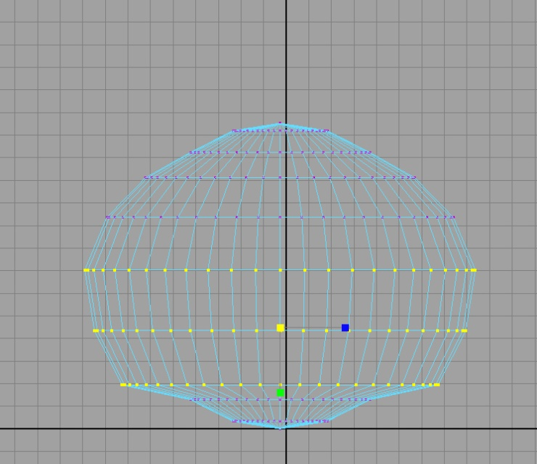
- Once again hold Ctrl-Left Click and drag a box over the top two rows of the selected vertices. This will deselect those rows.
- Scale the remaining selected row slightly in. See image below.
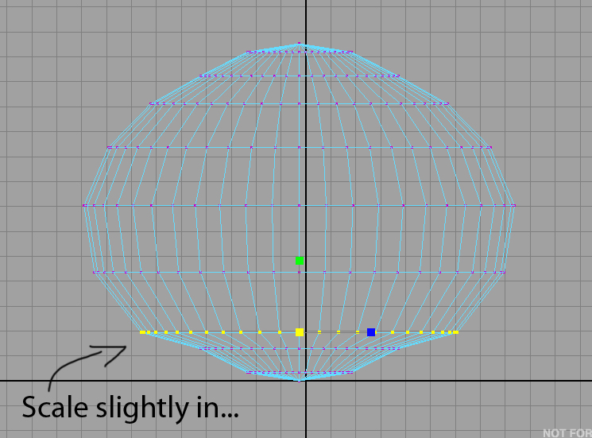
- Select the very bottom point of the sphere . Press the ‘W’ key to access the move tool. Move the bottom point in-line with the bottom row of vertices. (See image below)
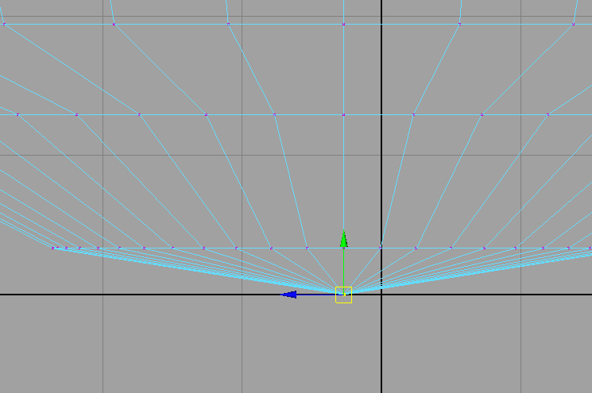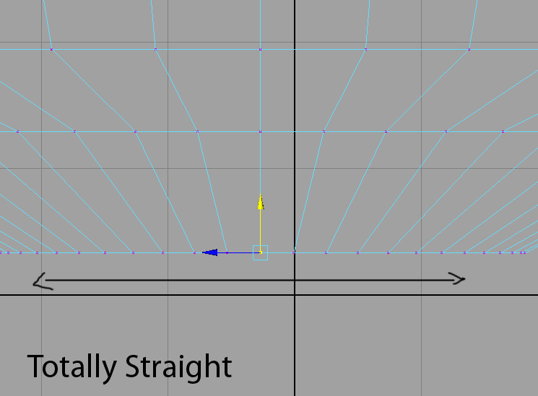
- Select the bottom two rows of vertices. Press the ‘R’ key to access the scale tool. Click on the green box and move it towards center until the bottom is rounded out. (See image below).
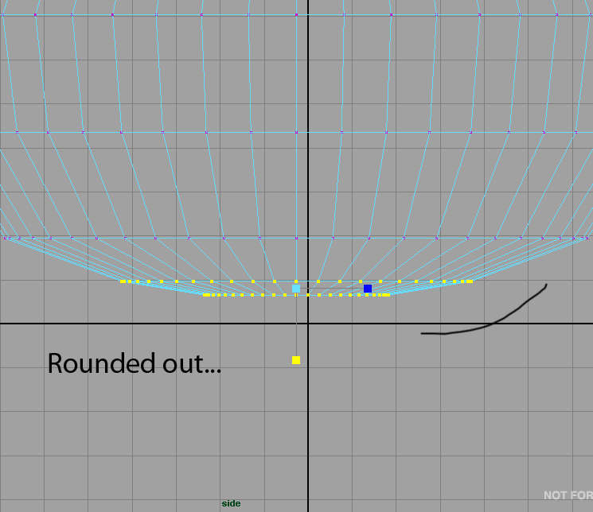

- Right-click on the image – drag to Edge. This will make the individual lines of the object active.
  - Near the top of our object select one edge in the 3rd row from the top. (See image below).
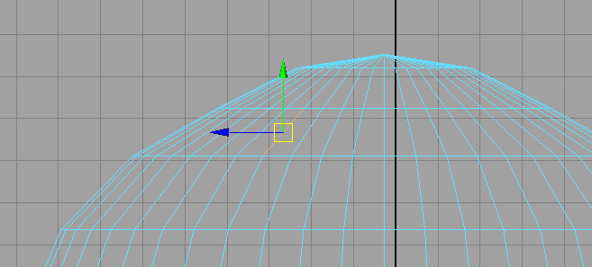
  - Hold down Ctrl-Right-Click and drag to ‘Edge Ring Utilities’. This will open another menu.
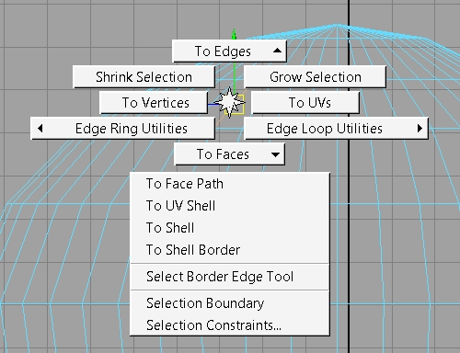
  - Choose ‘To Edge Ring and Split’. This will make a new row that bisects the selected edge.

- We will do this again in using a different set of commands. Select the Polygons tab near the top of the screen (See image below).
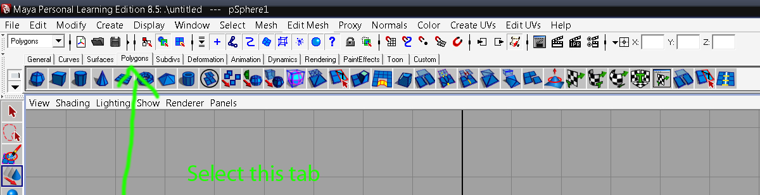
  - Right-Click the object – Choose ‘Object Mode’.
  - Hold down Ctrl-Shift – Mesh Tools – Insert Edge Loop tool. This creates a shortcut button at the end of the Polygons toolbar.
  - Select that new button.

  - Above the row we just created in the last step. Select one of the edges and create a new row (See image below).
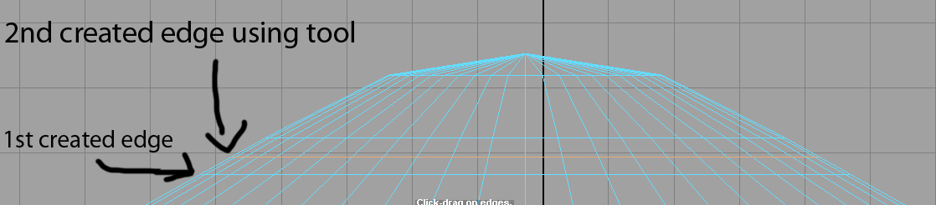
- While the new row is still selected, get the scale tool (‘R’ key), click on the yellow box and drag to the left to create a lid edge.
  - Get the move tool (‘W’ key) and click on the green arrow.
  - Drag down slightly (See image below).
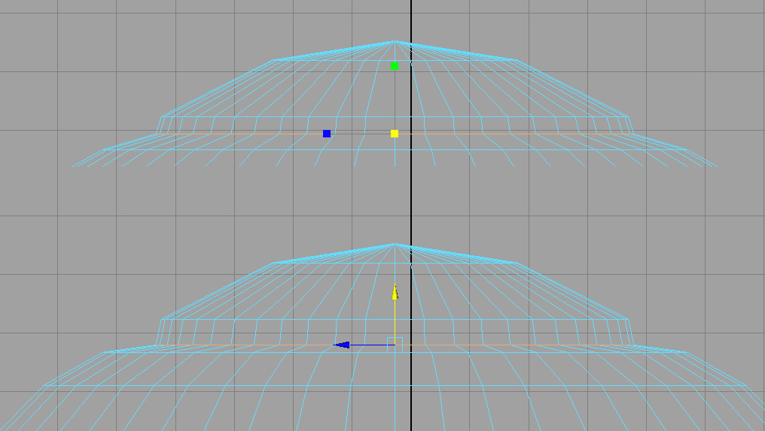
- Press the Spacebar. This will show the object from four different views. Click in the ‘Front’ panel.
  - Right-click on the object and drag to ‘Face’.
  - Select the four faces as per the image below. This will actually select the faces on the front and back of our object. Next we will deselect the faces on the back side.
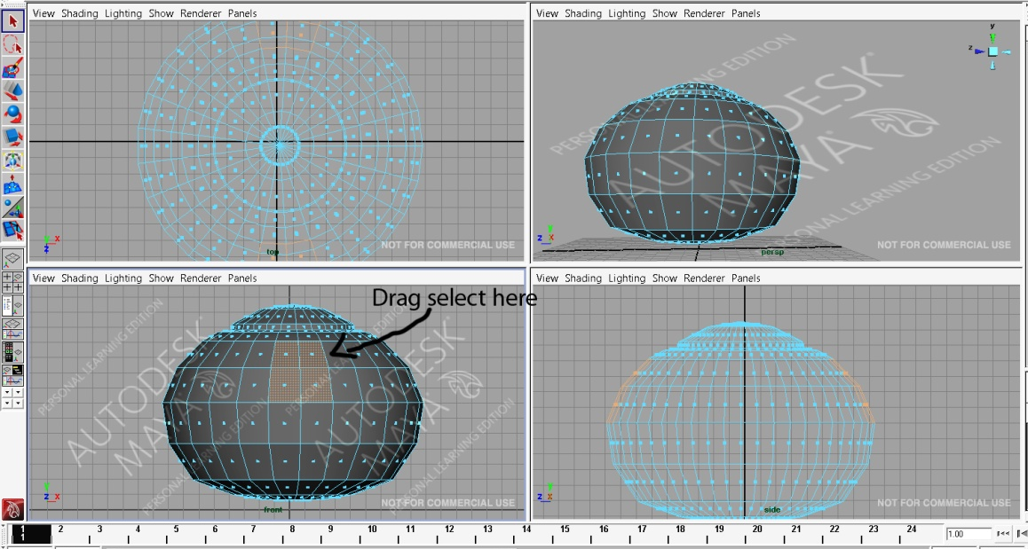

- Move to the ‘Side’ view pane
  - Hold down Ctrl and drag select the right side faces in order to deselect them. (See image below).
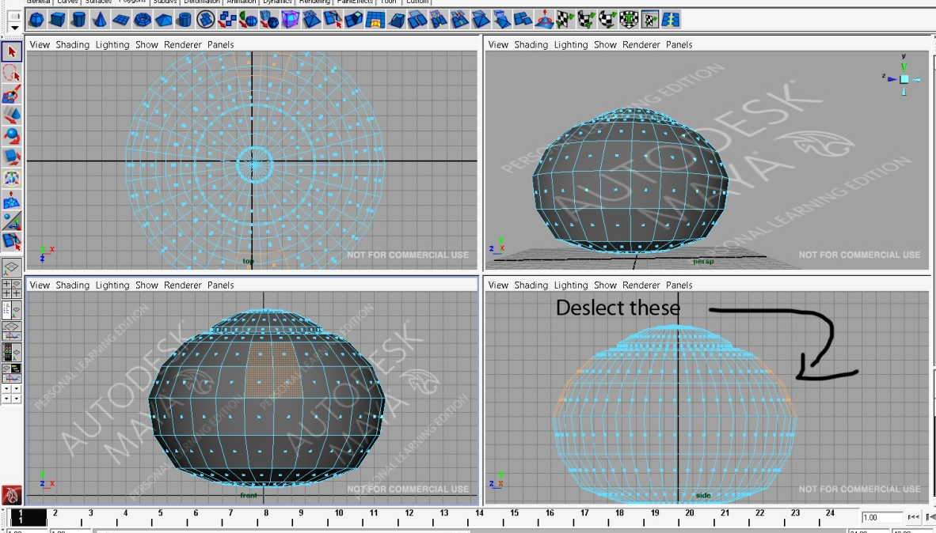

- Make the side view expand in the window by right clicking on it then pressing the Spacebar.
- From the Polygons shortcut toolbar select the ‘Extrude’ button. This will activate the extrude tool at the selected faces.
  - Select the Blue arrow and drag out the object. (See image below).
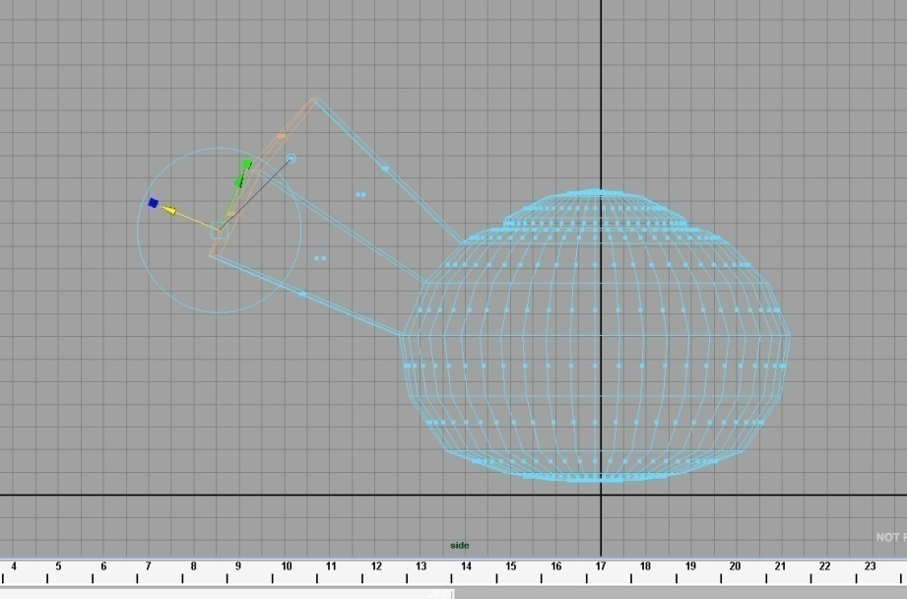
  - Select the scale tool (‘R’ key) and click on the yellow box.
  - Drag to the left to scale the edges down to make the end of the spout narrower. (See image below).
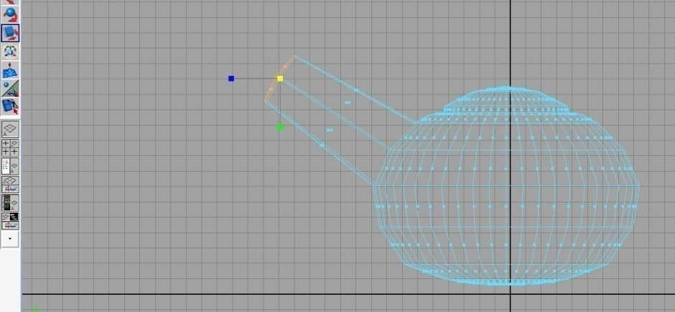
  - Select the ‘Extrude’ button again and move the blue arrow out again about ¾ of the length of the first extrusion.
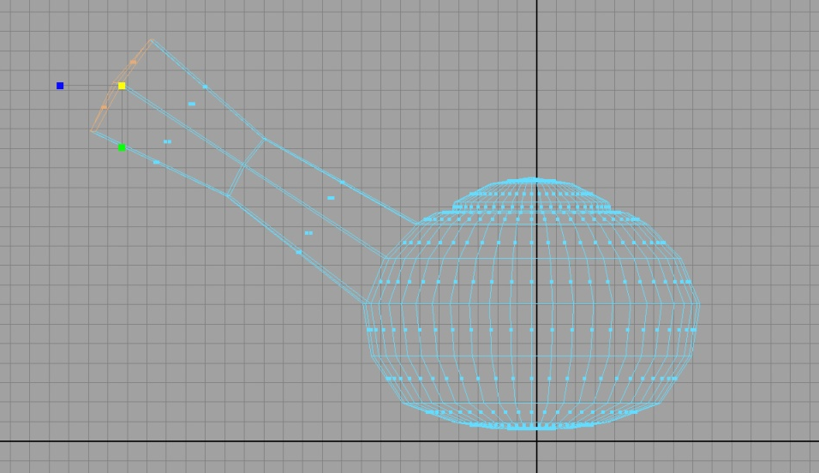
  - Select the scale tool (‘R’ key) and click on the yellow box.
  - Drag to the left to scale the edges down to make the end of the spout narrower. (See image below).
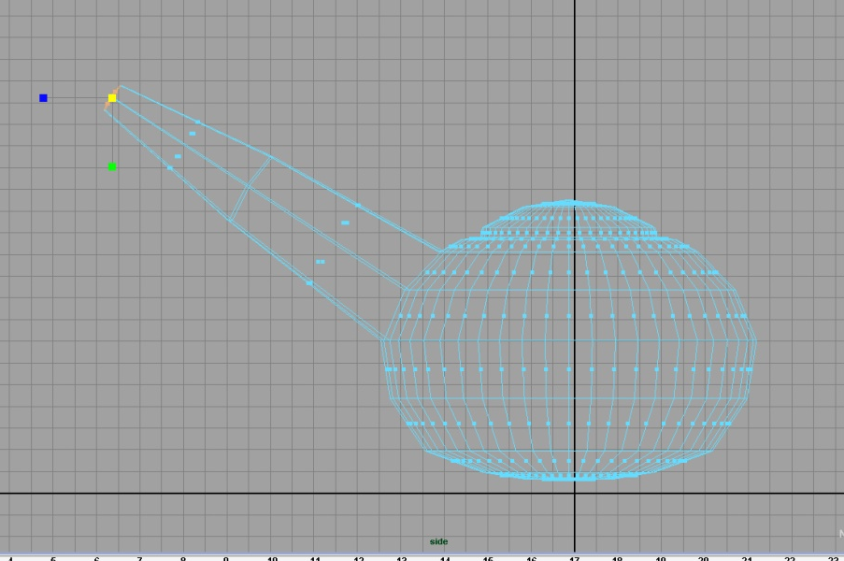
- Right-click object – drag to ‘Vertex’
  - Drag select the two sets of vertices that make up the spout.
  - Get the move tool.
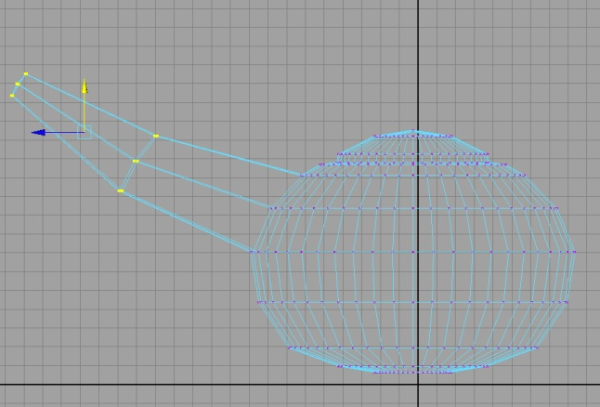
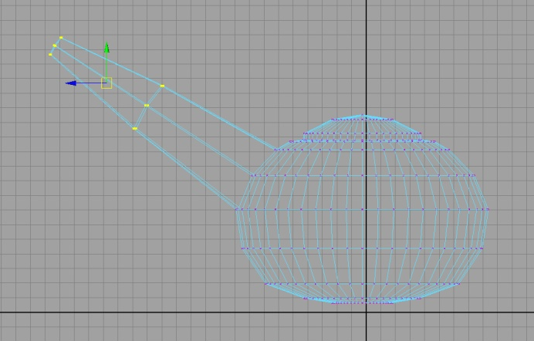
  - Use the green arrow to drag down slightly. This will bend the spout. (See image below).

- Select only the last row of vertices of the spout.
  - Use the move tool and the green arrow to move the end of the spout down.
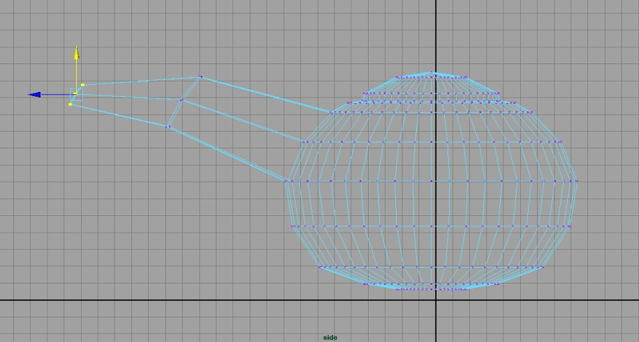
  - Press the ‘E’ key – this is the rotate tool.
  - Click and Hold on the red wheel (it will go yellow when properly selected).
  - Turn the wheel to the left so that the end of the spout is now perfectly vertical.
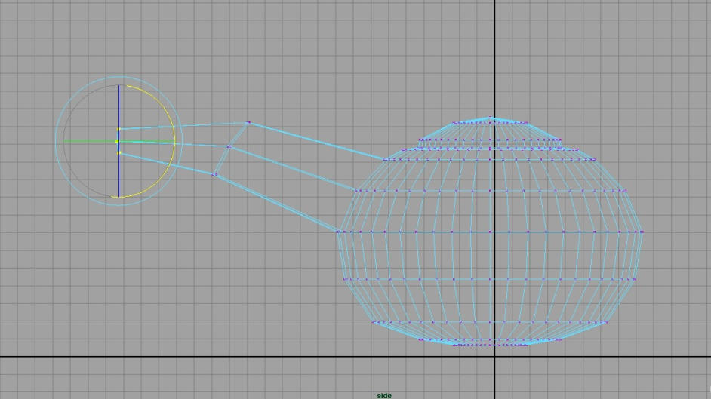
  - Select the vertices in the middle of the spout. Use the rotate tool to position them similar to the image below. This will make for a more naturally shaped spout when we smooth the image later.
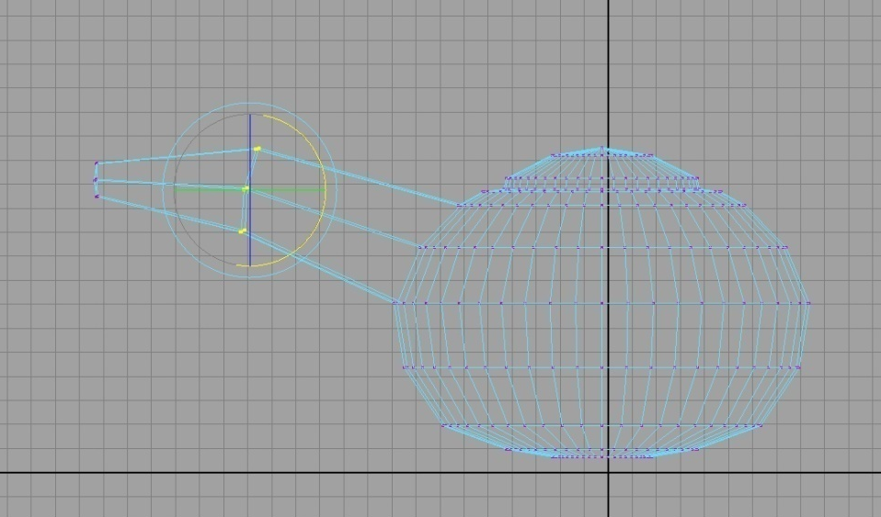

Handle Construction:
- Right-Click teapot – drag to ‘Face’ mode.
  - Select the face opposite the spout – 3rd row from the edge of the lid. (See image below).
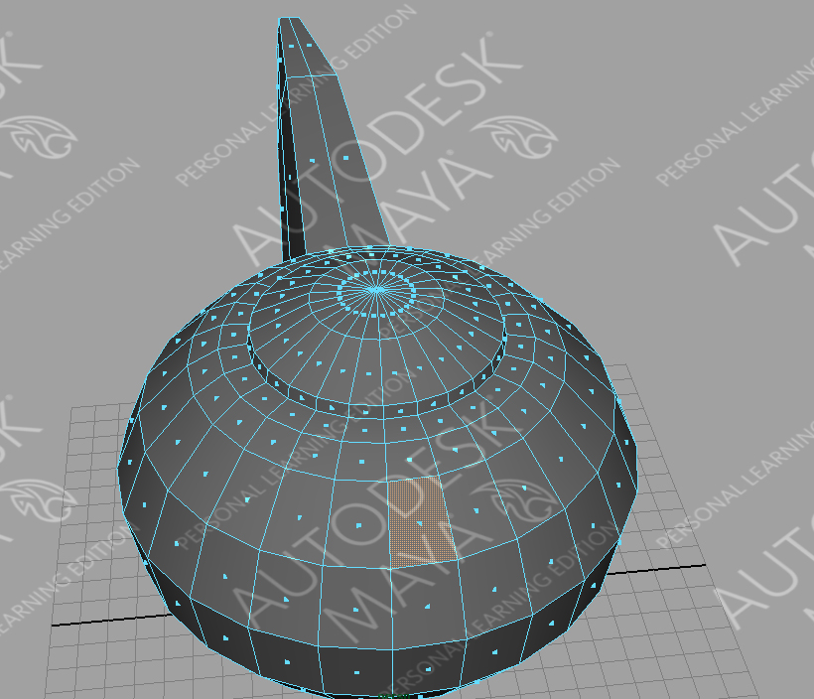
  - Select the ‘Extrude’ tool from the polygons shortcut toolbar. Extrude the face. (See image below).
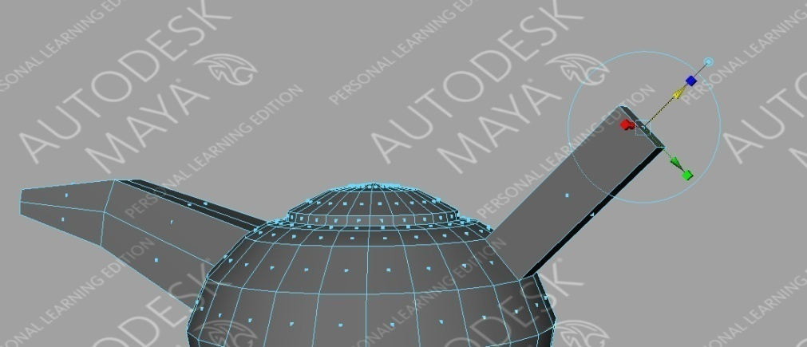
  - Select the ‘E’ key. This will activate the rotate tool. On the red axis pull down until the face of the handle is vertical. (See image below).
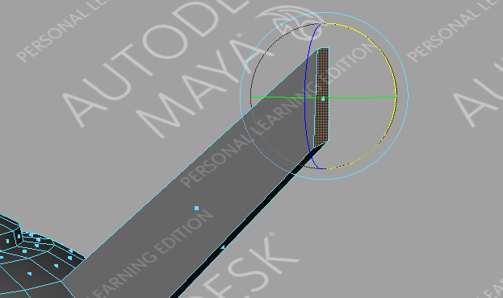
  - Use the ‘Extrude’ tool and pull out on the ‘z’ axis (blue axis) about half the distance of the first extrusion.
  - Activate the rotate tool again and rotate the face. (See image below).
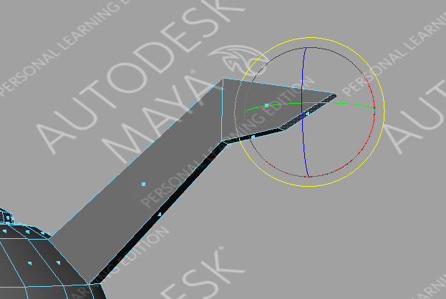
  - Repeat this process until your handle resembles the image below.
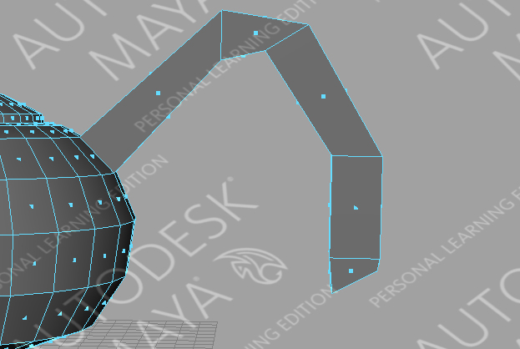

Shaping the Handle:
- Right-click teapot – drag to ‘Vertex’ mode.
  - Select the vertices at the top of the first extrusion. (See image below).
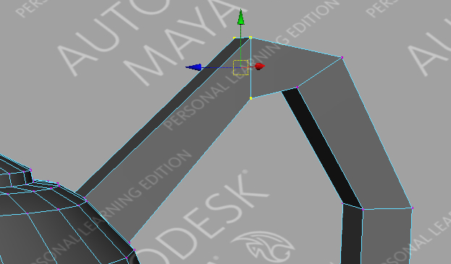
  - Activate the move tool.
  - Use the blue or green arrows (do not touch the red) to reposition the vertices to a more natural shape.
  - Continue this for the other extrusions until your handle looks similar to the image below.
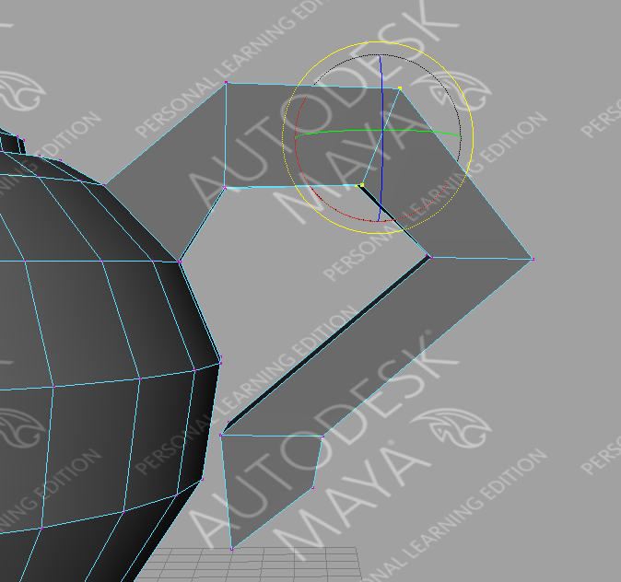

Final Touches:
- Change to side view. (Use the space bar to get there).

  - Select the very bottom ring of vertices – ensure the center point at the bottom of the teapot is in this selection.
  - Activate the scale tool ‘R’ key.

  - From the yellow centre box drag to the right in order to scale out. (See image below)
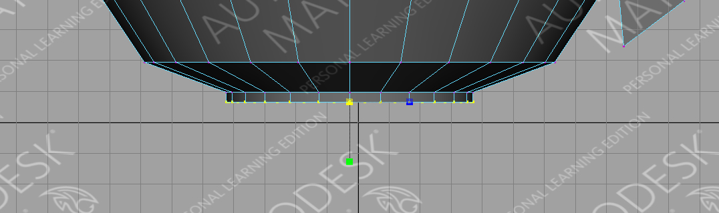
- Return to Perspective View (Use Spacebar).

- From the main menu choose ‘Mesh – Smooth(this will smoothen out your image by dividing in into many more polygons). (See image below)
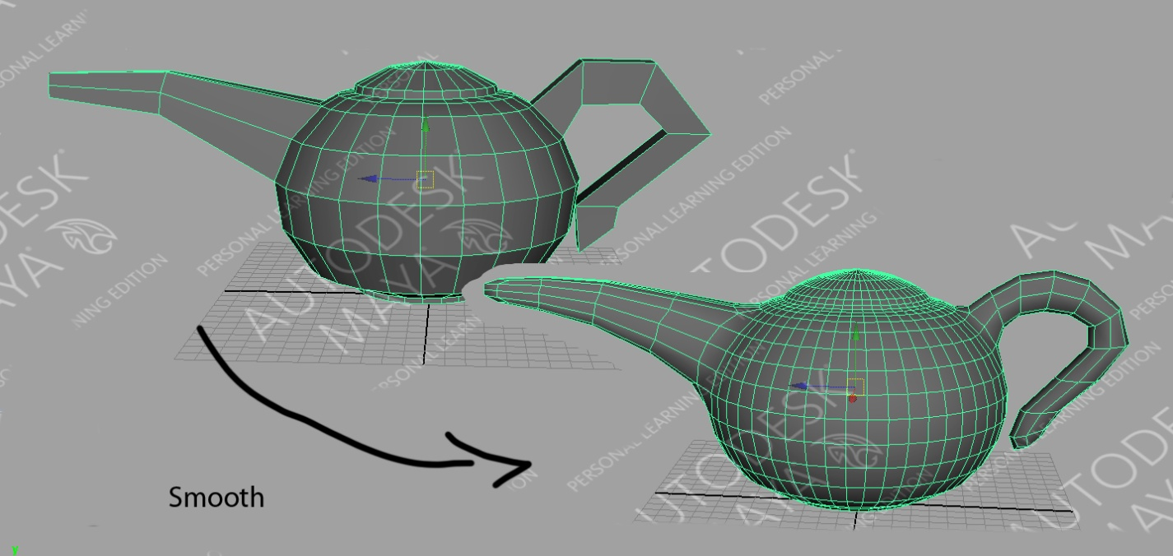1
- Right-click and drag to face mode.
  - Select the four faces at the tip of the spout.
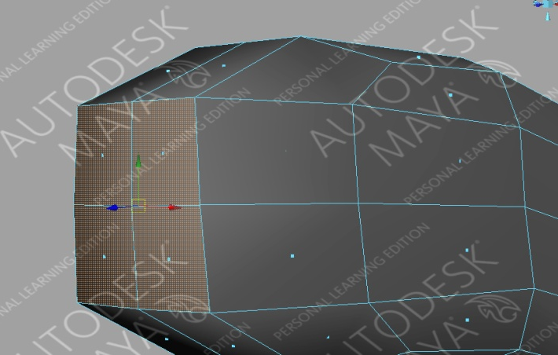
  - Select the ‘Extrude’ tool from the Polygons shortcut toolbar.

  - Click and drag on the blue arrow in order to move the end of the spout inside the spout. (See image below).
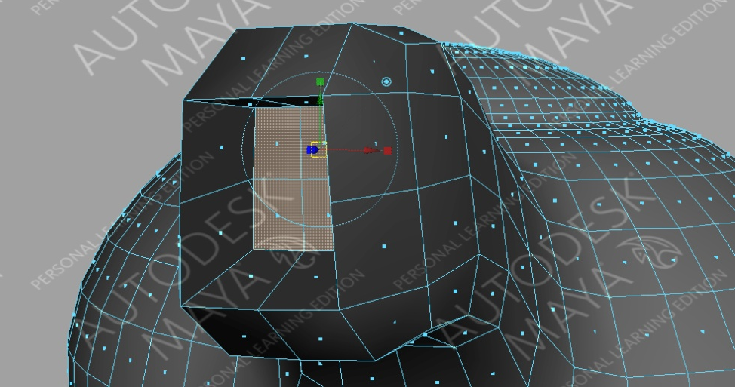
  - Right-click and drag to ‘Edge’ mode.
  - Select the edges as indicated by the arrows on the image below.
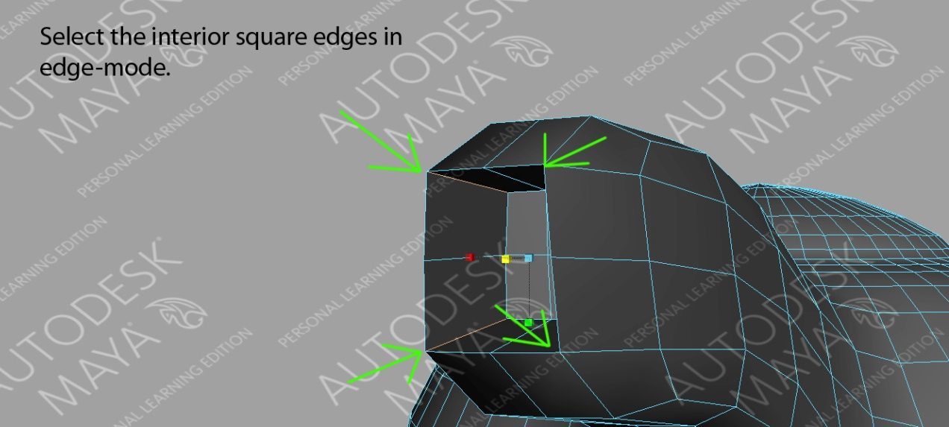
  - Press the ‘R’ key to get the scale tool
  - Hold down the Ctrl button
    - Select the blue box
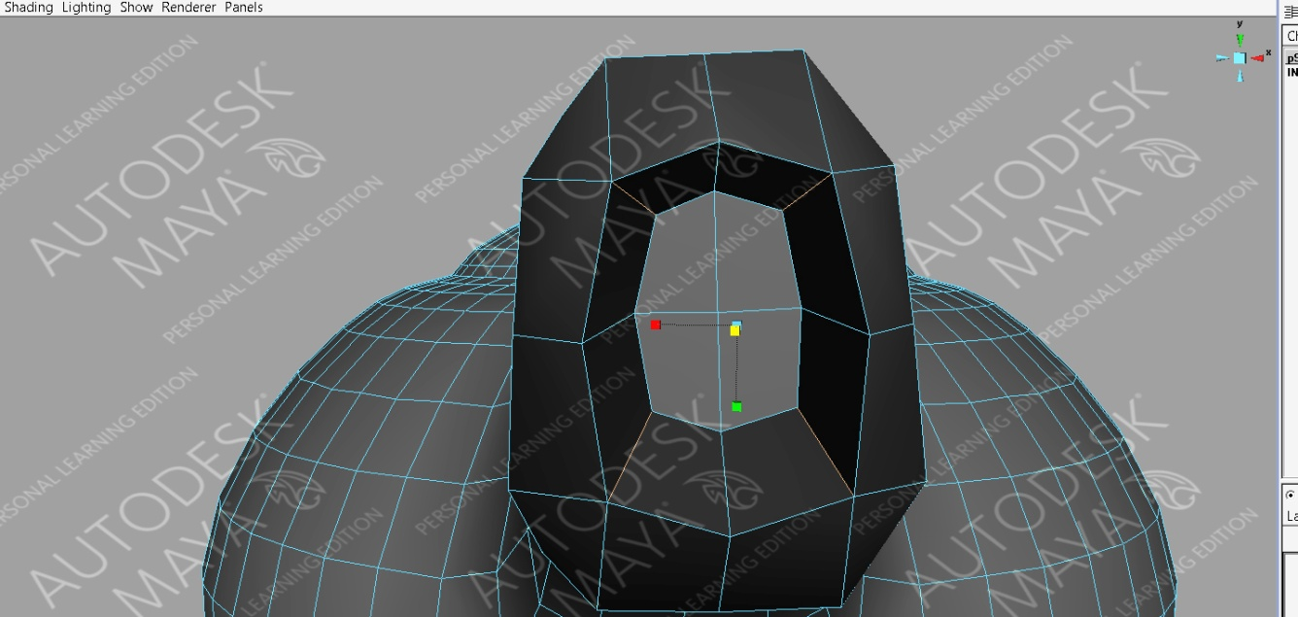
    - Drag slightly to the left to open the end of the spout (See image below).

Applying Materials:
- Right-click teapot – drag to ‘Object’ mode.
  - Select teapot
  - Right-click and drag down to ‘Assign New Material – Blinn’ (Blinn will give us a shiny surface).
  - This will open the materials attribute panel on the right side of the screen.
  - Under ‘Specular Shading’ change the values to those seen in the image below.
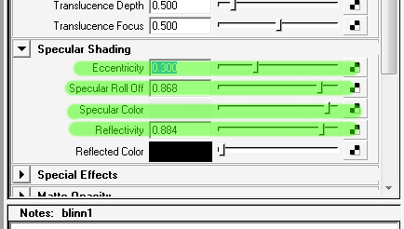
  - Under ‘Common Material Attributes’ click on the rectangle next to ‘Color’. The ‘Color Chooser’ will appear.
    - Select an appropriate color for your teapot.

OOOOPS! We forgot to make a knob to lift the lid.
Make a knob on top of the teapot using ‘Vertex’ mode, the edge loop tool, and only the move and scale tools. This will have to be completed in wireframe mode. (See image below).



