Maya Tutorial 3: Rocket
So let’s begin with a simple spaceship and rocket boosters. Let’s begin by creating a polygon cylinder to serve as the spaceship’s body:
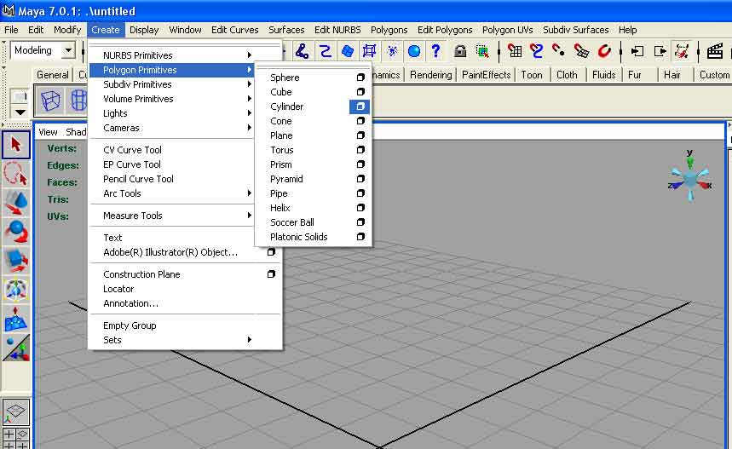
This will bring up a property page wherein you should fill the following parameters:
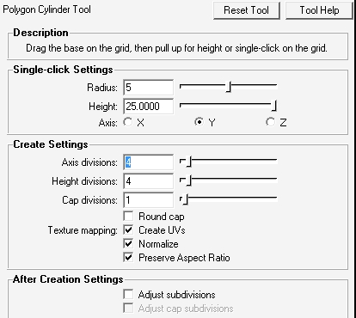

Doing so will produce something like what you see in the illustration below:
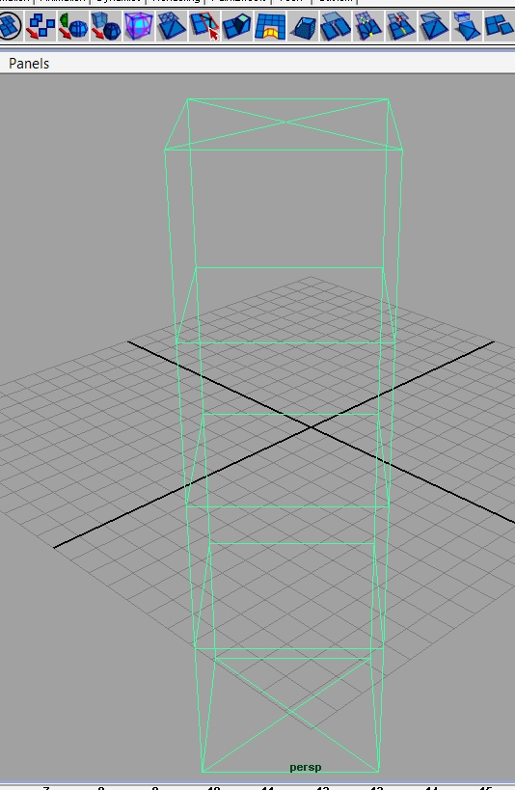
Now let’s rotate it 90 degrees in the x axis, and in the perspective view turn on Shading-> Smooth Shade All and Hardware texturing.
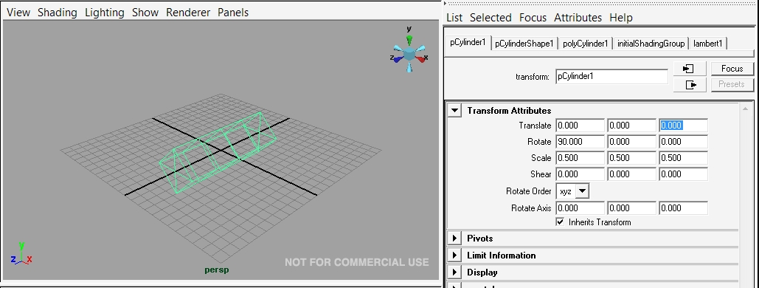
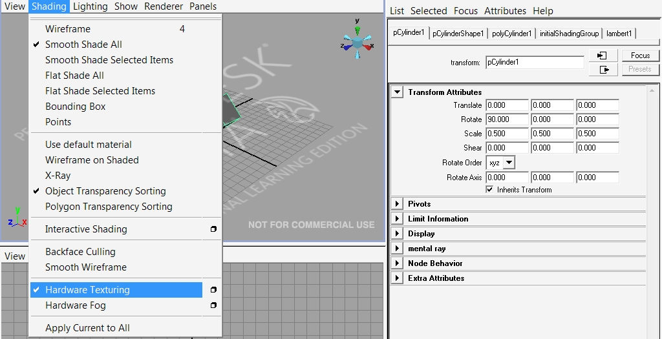
Now create a polygon cone with the following parameters:
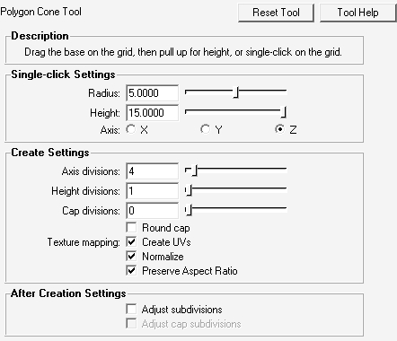
Next we need to rotate and align the cone so that it sits at end of your cylinder.
- Select the cone and rotate if necessary in order to put it in the same horizontal alignment as the cylinder. See Below.
- Next select the move tool.
  - Hold down the ‘D’ and ‘V’ keys at the same time. Your move tool will go from having a square centre to a round centre.
  - LeftClick and drag the centre of your move tool to the top vertex of your cone. (shown below).
  - Release the ‘D’ key – keep the ‘V’ key pressed. Drag the centre of the move tool to the top vertex of your cylinder. This will automatically line up the top of the cone and the cylinder.
  - If necessary use the scale tool to make edges of the cone line up with the edges of the cylinder. (See image below)
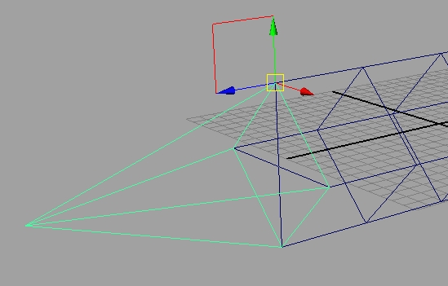
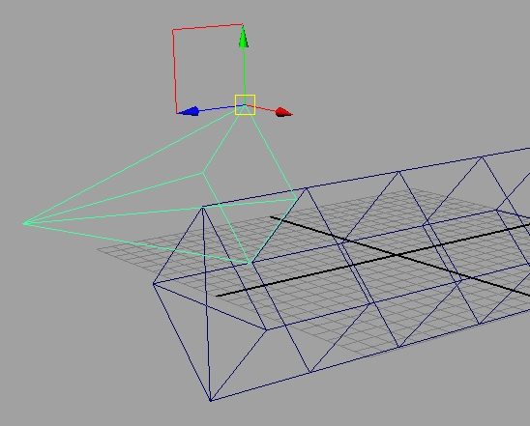
Now we need to add more faces to each of our objects.
- Select the cylinder.
  - Use Ctrl-A to toggle to the Channels Object pane on the right side of the screen.
  - Under ‘Inputs’ click on ‘polyCylinder1’ and change the settings to those below.
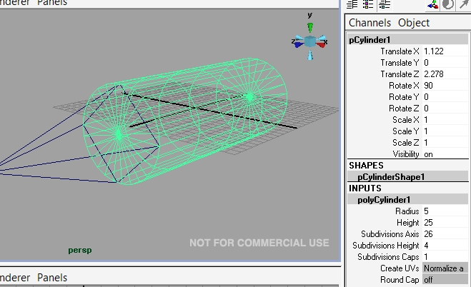

- Select the cone.
  - Click on ‘polyCone1’ and set the ‘Subdivision Axis’ to 26. Your project should now look similar to the image below.
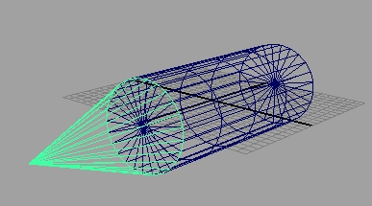

Next we need to make the cone and the cylinder a single object. In order to do so we have to eliminate the faces separating the two and merge their common vertices together.
- To make the cylinder and the cone one - Select both objects.
  - From the main menu select Mesh -> Combine
  - Hold down the RightClick button on the selected combined object – a menu pops up.
  - While holding down the RightClick button and drag to faces. The object turns light blue.
  - Use the selection tool to select only the common faces between the cone and the cylinder. See below. You will have to get inside the mesh in order to do this.
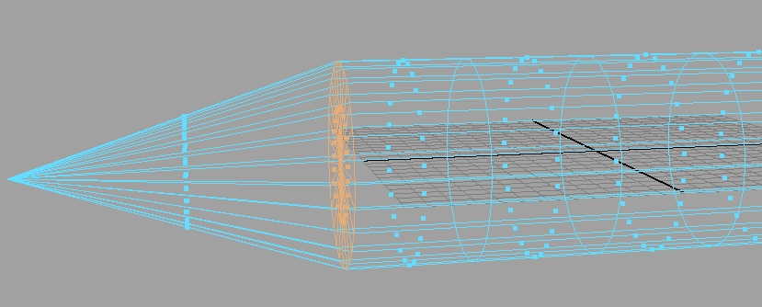
  - Hit the delete key. The highlighted faces should disappear.

This next step requires some patients and some careful work. Although the two objects appear to be one, there are now 2 vertices at the 26 points where the objects meet. We need to merge these vertices together so that there is only one vertex at each point.
- RightClick on the object and drag to ‘Vertex’
  - Use the selection tool to drag-select a single vertex intersection (if you just click on the intersection you will only get one of the two vertexes you want to merge).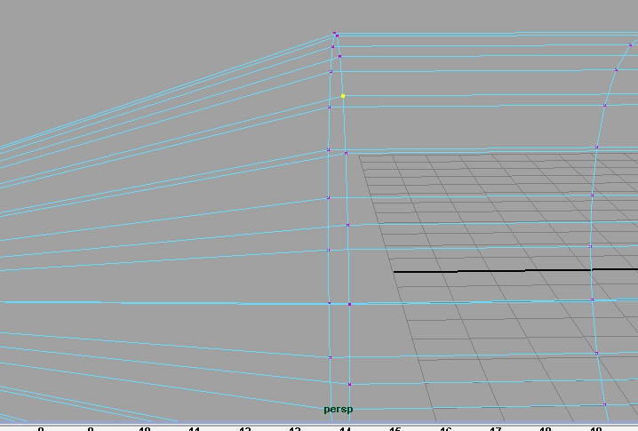
  - From the main menu choose EditMesh -> Merge
  - Drag-select another intersection. Press the ‘G’ key. This repeats the EditMesh -> Merge command.
  - Continue for the remaining 24 common vertices.
  - When complete RightClick on the object and select ‘Object Mode’.
The next step is to make a set of wings for our object.
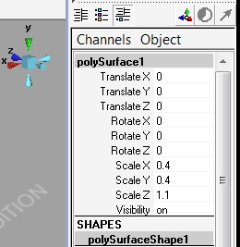
- Make your object thinner and a little longer use the settings below in the ‘Channels Object’ panel. (Use Ctrl-A to scroll through the panels if necessary.)
- Select keys 4 and 5 in order to show the wire frame and a solid surface behind it. This will make it easier for you to make your next selections.
  - RightClick on the object and select ‘Edge’ from the pop-up menu.
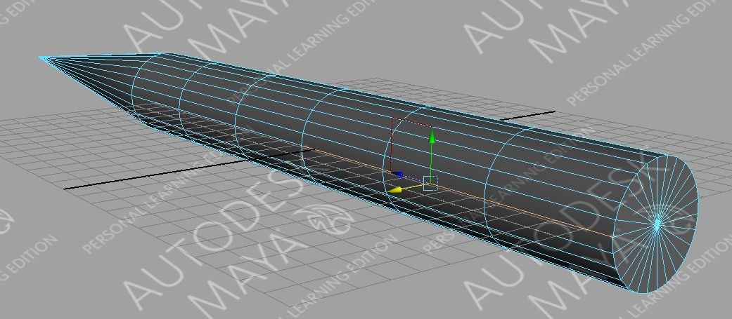
  - Hold down the ‘Shift’ key and select the three edges closest to the back of the cylinder that are run parallel with the grid. (See below)

  - Press the ‘W’ key. This selects the move tool. Drag the selected edges out to the edge of the grid.
  - Repeat for the other side.
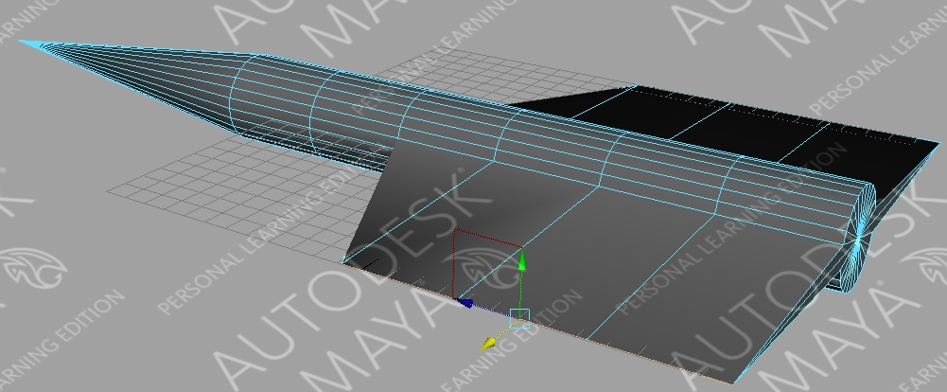
Building the tail section comes next.
- Select the top two edges at the back of the cylinder.
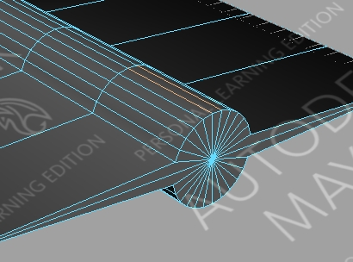

- Press the ‘W’ key to select the move tool. Move the edges upward to produce the tail section.
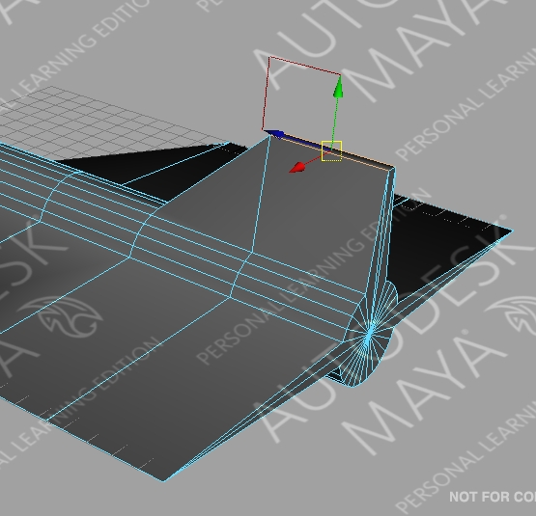

Adding Colour
- RightClick on object and select ‘Face’.
- Use the select tool to drag-select only the cone portion of the object.
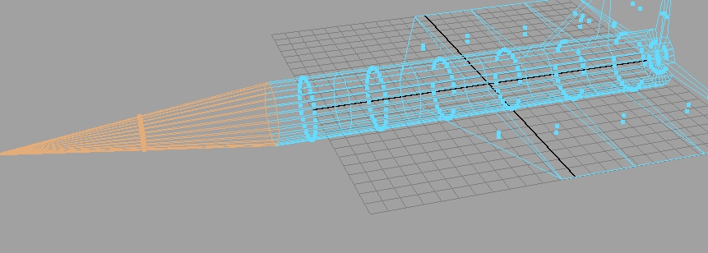
- RightClick on the object and choose ‘Add New Material’ -> Lambert.
  - The materials attribute panel appears on the right of the screen.
  - Click on the grey box next to ‘Color’ to open the ‘Color Chooser’
  - Select a color of your liking an select ‘Accept’
  - Move the slide next to ‘Ambient Color’ to just over the halfway mark (See image below)
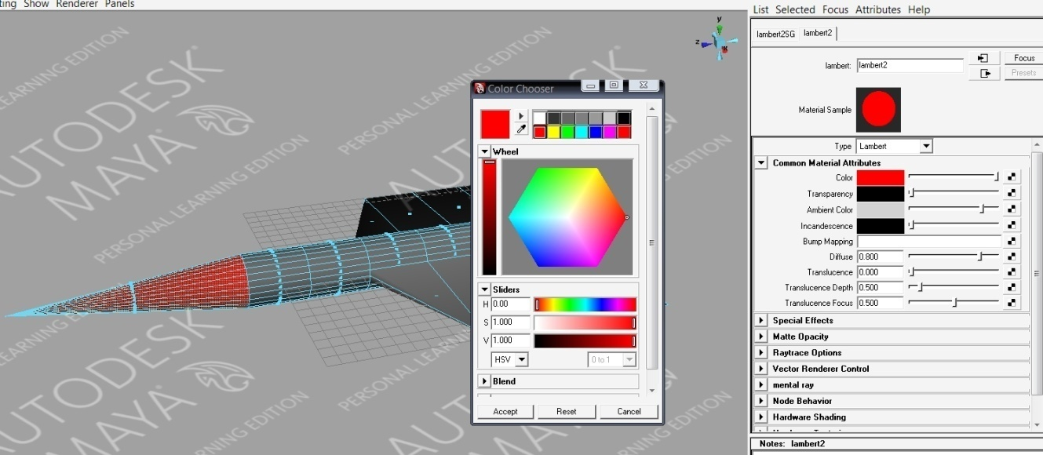
- To colour the rest of the object - Select the rest of the body and repeat steps 1 through 3.

Adding Booster Engines.
- Create a new cylinder with the following attributes.
  - Subdivision Axis: 26
  - Subdivision Height: 5
  - Scale it to be thinner and shorter than the original object
  - Align it to sit parallel to the original object
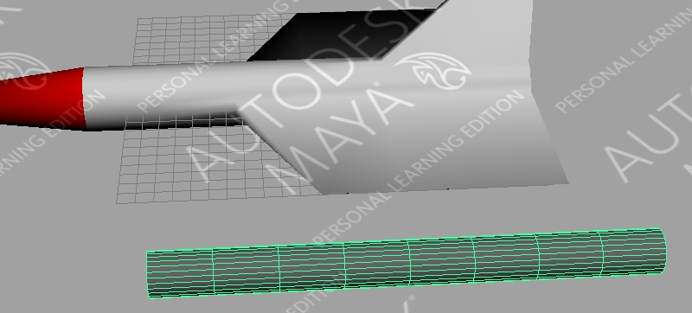
- RightClick on the Rocket Booster cylinder and drag to ‘Vertex’.
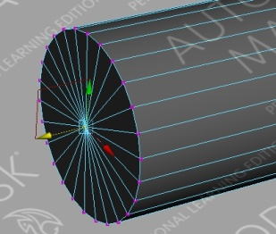
- Move to one end of the cylinder and drag-select the middle vertex intersection.

- Move the vertex out to produce a cone shape.
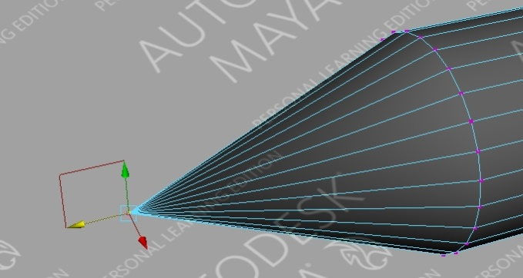
- Move to the other end of the cylinder and select the first ring of vertices in from the end of the cylinder. Use the move tool to move the selected vertices closer to the end of the cylinder. (See below)
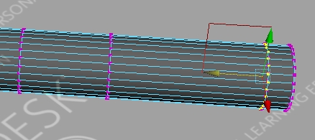
- Next, select only the vertices at the end of the cylinder. Press the ‘R’ key to access the scale tool. Use the scale tool to expand the radius of the selected vertexes. (See below)
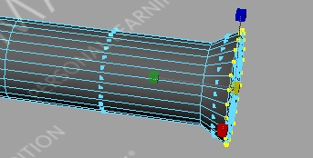
- RightClick on the rocket booster and drag to ‘Faces’.
- Final steps now (whew, finally)
  - Apply colour to your booster rocket as described in the steps above.
  - RightClick and select ‘Object Mode’
  - Scale your booster rocket to an appropriate size for your initial rocket.
- Now we are going to remove all of the hard edges.
  - Select both objects.
  - From the main menu choose Mesh -> Smooth. Do this one more time.
- Select only your booster rocket – main menu – Edit -> Duplicate. This gives you a second booster rocket.
  - Use the move tool to position both booster rockets appropriately
  - When in position select all objects the go to the main menu and choose Mesh-> Combine. (Final product shown below.)



